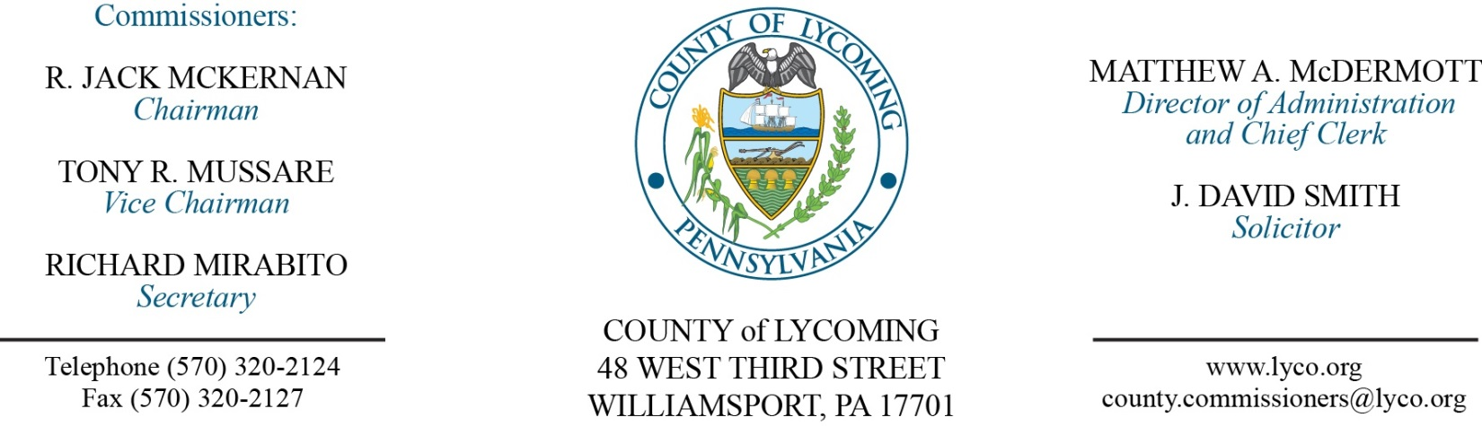
Commissioners’ Meeting Agenda
December 1, 2016

Opening Prayer

Pledge to the Flag

1.0 OPERATIONS

1.1 Convene Commissioners’ meeting.

1.2 Approve the minutes of the previous meetings.

1.3 Receive public comments (agenda items only).

2.0 ACTION ITEMS

2.1 Approve sub grant agreement with STEP for 2014 CDBG in the amount of $39,888 for the Homes in Need Program. (Kristin McLaughlin)

2.2 Approve agreement with Williamsport Sun-Gazette for Advertising in 2017. (Mya Toon)

2.3 Approve agreement with Larson Design Group for courthouse wastewater back up issue. (Mya Toon)

2.4 Approve professional service agreement with Swift Reach Inc. for a period of one year not to exceed $24,995. (John Yingling)

2.5 Approve agreement with US SBA for Office of Disaster Assistance space agreement and authorize Director of Administration to sign. (John Yingling)

2.6 Approve amendment 1 to professional service agreement with the Girio Agency, Inc. for 2016 Real Estate Appraisals. (Josh Schnitzlein)

2.7 Approve professional service agreement with Michael Baker increasing it by $25,000. (Josh Schnitzlein)

2.8 Approve professional service agreement with Valley Youth House for JPO. (Nancy Ackley)

2.9 Approve professional service agreement with Outside In for JPO. (Nancy Ackley)

2.10 Award contract to Truck & Trailer Sales for 4-Used 53 Foot Dry Cargo Van Trailers in the amount of $41,000. (Michael Hnatin)

2.11 Approve Human Resources Report through November 30, 2016. (Ann Gehret)

2.12 Approve professional service agreement with Hartman Employee Benefits not to exceed $15,000. (Matt McDermott)

Recess Commissioners’ Meeting

4.0 BOARD of ASSESSMENT REVISION

4.1 Convene Board of Assessment Revision.

4.2 Approve the following real estate refunds:
Jerre & Judith Longenecker in the amount of $44.88.
Donald & Sandra Swarthout in the amount of $34.16.
Charles Trudeau in the amount of $10.81.
Chad & Brenda Hall in the amount of $168.43.
George Landgrebe in the amount of $14.22.
May Dept Stores in the amount of $29705.11.
Peter Koch in the amount of $22.82.

4.3 Approve the following real estate exonerations:
Parcel Name Address
31-346-114-001 Jeff Liddic & Beth Miller 3026 Canoe Run Rd.
60-367-125.G-050 Kristyane Kronicz 50 Harvest Moon Pk
59-004-295 Elton & Mary Treese 190 Aderhold Dr.

4.4 Adjourn Board of Assessment Revision.

Reconvene Commissioners’ Meeting

5.0 REPORTS/INFORMATION ITEMS

5.1 Present the following service awards:
10 years:
Rodney Paulhamus Maintenance.
Bryan Bower APO.
30 years
Scott Metzger APO.

6.0 COMMISSIONER COMMENT:

7.0 PUBLIC COMMENT:

8.0 NEXT REGULARLY SCHEDULED MEETING: Planning Session on Tuesday, December 6, 2016.

9.0 ADJOURN COMMISSIONERS’ MEETING.

