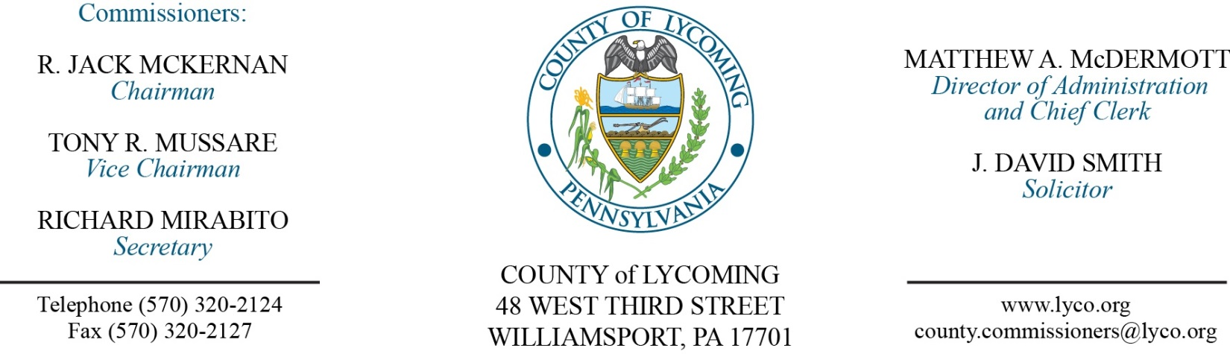
Commissioners’ Meeting Agenda
December 20, 2016

Opening Prayer

Pledge to the Flag

1.0 OPERATIONS

1.1 Convene Commissioners’ meeting.

1.3 Receive public comments (agenda items only).

2.0 ACTION ITEMS

2.1 Adopt Resolution 2016-30 for the 2017 Budget. (Beth Johnston)

2.2 Adopt Resolution 2016-31 setting the millage rate for 2017. (Beth Johnston)

2.3 Adopt Resolution 2016-32 setting the pre-determined ratio for 2017. (Beth Johnston)

2.4 Adopt Resolution 2016-28 for the TDA. (Ann Gehret/Roxanne Grieco)

2.5 Approve update to County Policy and Procedures Manual for the following policies: 400 (job code listing) and 401 (pay scale). (Ann Gehret/Roxanne Grieco)

2.6 Approve the Amended professional service agreement with GEO Re-Entry Services. (Matthew McDermott)

2.7 Adopt resolution 2016-34 authorizing sale real property on Warrensville Road previously awarded on November 3, 2016. (Matthew McDermott)

5.0 INFORMATION ITEMS

5.1 Notification of requests to be submitted for state capital budget. (Kurt Hausammann)

6.0 COMMISSIONER COMMENT:

7.0 PUBLIC COMMENT:

8.0 NEXT REGULARLY SCHEDULED MEETING: Planning Session on Tuesday, January 3, 2017.

9.0 ADJOURN COMMISSIONERS’ MEETING.

