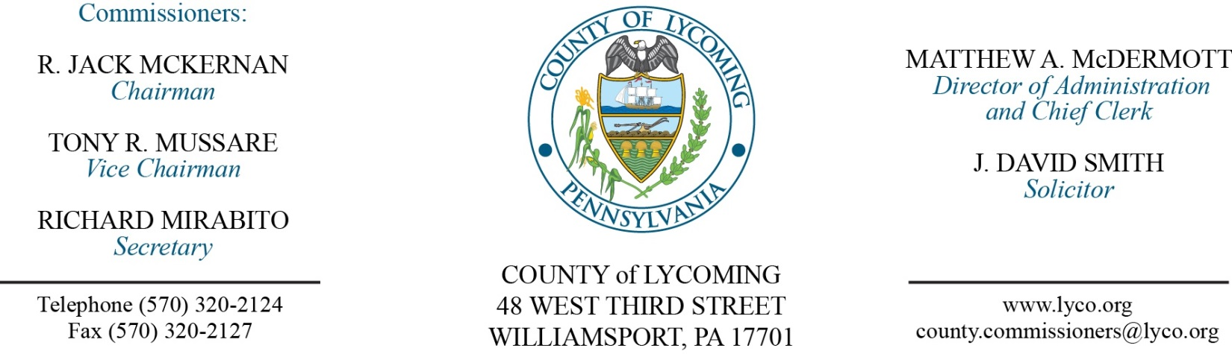
Commissioners’ Meeting Agenda
January 5, 2017

Opening Prayer

Pledge to the Flag

1.0 OPERATIONS

1.1 Convene Commissioners’ meeting.

1.2 Approve the minutes of the previous meetings.

1.3 Receive public comments (agenda items only).

2.0 ACTION ITEMS

2.1 Approve professional service agreement with Sungard for eFinance. (Jerry Kennedy)

2.2 Approve invoice from Teleosoft for Orphan’s Maintenance Fee in the amount of $12,500. (Jerry Kennedy)

2.3 Approve amendment to agreement with Arraya Solutions. (Jerry Kennedy)

2.4 Approve amendment 2 to professional service agreement with Montoursville Borough for Indian Park & Nature Trail. (Kurt Hausammann)

2.5 Approve amendment 2 to professional service agreement with McCormick Law Firm for solicitor services extending it to February 28, 2017. (Kurt Hausammann)

2.6 Approve professional service agreement with Delta Development for 2017. (Kurt Hausammann)

2.7 Approve professional service agreement with SEDA COG for FFY 2015. (Megan Lehman)

2.8 Approve agreement with David Wilk, Esq. for Solicitor for Collections Office. (Tom Heap)

2.9 Approve professional service agreement with Columbia County for Inmate Housing. (Mya Toon)

2.10 Approve invoice from Dominion Voting in the amount of $20,889.00 for an annual licensing agreement. (Forrest Lehman)

2.11 Approve workers compensation agreement with Henry Dunn agency for AmeriHealth. (Ann Gehret)

2.12 Approve the following personnel actions: (Roxanne Grieco)
Veterans Affairs – reclassification of David A. Keene as full time Veterans Affairs Assistant – Pay grade 7 - $19.44/hour effective 1/1/17.
Veterans Affairs – reclassification of Natalie Steppe as full time Clerk IV – Pay grade 5 - $16.51/hour effective 1/1/17.
Fiscal Services – reclassification of Lori L. Weston as full time Lead Fiscal Technician – Pay grade 7 - $23.08/hour effective 1/1/17.
Human Resources – reclassification of Lauren K. Bower as full time HR Generalist – Pay grade 9 - $44,200.45/annually effective 1/1/17.
Human Resources – reclassification of Rebecca A. Praster as part time Clerk III – Pay grade 4 - $15.09/hour effective 1/1/17, not to exceed 1,000 hours annually.
Information Services – reclassification of Gary L. Fox as full time Printer – Pay grade 7 - $22.89/hour effective 1/1/17.
PCD – reclassification of Joshua Schnitzlein as full time Hazard Reduction Planner – Pay grade 9 - $42,179.89/annually effective 1/1/17.
DPS - EMA – reclassification of Daniel N. Dorman as full time EMA Manager – Pay grade 11 - $75,877.21/annually effective 1/1/17.
DPS - Communications – Matthew Oldt, II as full time Telecommunicator I – WOE - Pay grade 6 - $16.59/hour effective 1/16/17.
Courts – reclassification of Libby L. Williams as full time Clerk IV – Pay grade 5 - $15.95/hour effective 1/1/17.
APO – reclassification of Suzanne Croteau as full time Clerk IV – Pay grade 5 - $20.85/hour effective 1/1/17.
Prison – reclassification of Phillip Keeler as full time Maintenance III (Electrical) – Pay grade 8 - $24.59/hour effective 1/1/17.
Coroner – reclassification of Jennifer L. Nolan as full time Deputy Coroner – Pay grade 7 - $21.54/hourly effective 1/1/17.
District Attorney – Suzette M. Shipman as part time Clerk I – Pay grade 2 - $10.94/hour effective 1/9/17, not to exceed 1,000 hours annually.
Prothonotary – reclassification of Kevin S. Williams as full time Deputy – Pay grade 8 - $38,548.49/annually effective 1/1/17.
Sheriff – reclassification of Amanda K. Bess as full time Clerk III – Pay grade 4 - $13.95/hour effective 1/1/17.
Sheriff – reclassification of Eric T. Spiegel as full time Sergeant – Pay grade 8 - $21.12/hour effective 1/1/17.
Sheriff – reclassification of Jason J. Sparks as full time Sergeant – Pay grade 8 - $22.64/hour effective 1/1/17.
Sheriff – reclassification of Matthew J. Kula as full time Sergeant – Pay grade 8 - $21.46/hour effective 1/1/17.

2.12 Accept Human Resources Report through December 31, 2016. (Roxanne Grieco)

Recess Commissioners’ Meeting

3.0 SALARY BOARD

3.1 Convene Salary Board.

3.2 Adopt salary scale for year 2017.

3.3 Approve Table of Distribution and Authorizations for 2017.

3.4 Adopt Salary Schedule for 2017.

3.5 Adjourn Salary Board.

Reconvene Commissioners’ Meeting

6.0 COMMISSIONER COMMENT:

7.0 PUBLIC COMMENT:

8.0 NEXT REGULARLY SCHEDULED MEETING: Planning Session on Tuesday, January 10, 2017.

9.0 ADJOURN COMMISSIONERS’ MEETING.

