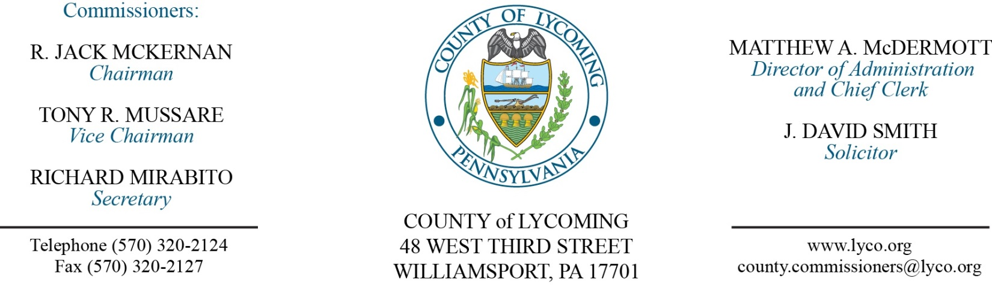
Commissioners’ Meeting Agenda
January 26, 2017

Opening Prayer

Pledge to the Flag

1.0 OPERATIONS

1.1 Convene Commissioners’ meeting.

1.2 Approve the minutes of the previous meetings.

1.3 Receive public comments (agenda items only).

2.0 ACTION ITEMS

2.1 Approve professional service agreement with EIHAB Human Services for the Juvenile Probation office for Shelter Care Services (Nancy Ackley)

2.2 Approve professional service agreement with C. Townsend Velkoff for the Juvenile Probation office for counseling services and assessments (Nancy Ackley)

2.3 Approve professional service agreement with Alternative Rehabilitation Communities for the Juvenile Probation office for treatment (Nancy Ackley)

2.4 Approve Equitable Sharing Agreement and Annual Certification Report with the District Attorney (Eric Linhardt)

2.5 Approve payment of invoice to CyberGenetics in the amount of $15,033 (Eric Linhardt)

2.6 Award RFP for Planning and Zoning Solicitor services to McCormick Law Firm (Kurt Hausammann)

2.7 Approve Dell Marketing LP professional service agreement (Mya Toon)

2.8 Approve invoice for Forensic Bioinformatic Services Inc in the amount of $14,347.02 for the Public Defender’s office (Mya Toon)

2.9 Approve Memorandum of Understanding between County of Lycoming and Constable, Chad Riley (John Yingling)

2.10 Approve the January, 2017 Human Resource Report (Roxanne Grieco)

2.11 Approve Alexandria H. Gstalder – Cooperative Extension – full time replacement 4-H Program Assistant – paygrade 7 - $18.08 per hour effective 1/30/17 (Roxanne Grieco)

2.12 Approve Leslie Kilpatrick – Information Services – Reclassification to fully qualified Systems Support Manager – Paygrade 11 - $67,888.78 per year effective 1/29/17 (Roxanne Grieco)

5.0 REPORTS/INFORMATION ITEMS

5.1 Lycoming County is request bids for Food Products 2nd quarter, 2017.

6.0 COMMISSIONER COMMENT:

7.0 PUBLIC COMMENT:

8.0 NEXT REGULARLY SCHEDULED MEETING: Planning Session on Tuesday, February 7, 2017.

9.0 ADJOURN COMMISSIONERS’ MEETING.

