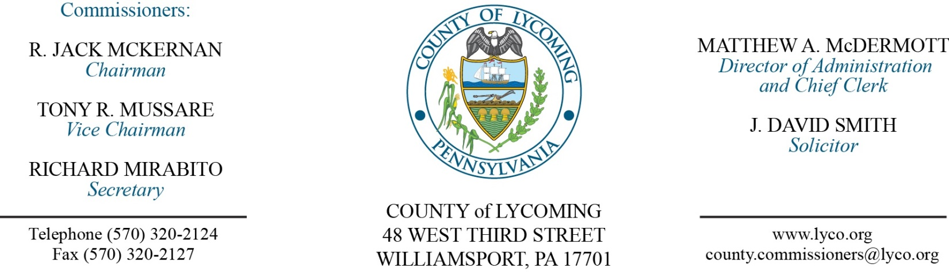
Commissioners’ Meeting Agenda
March 23, 2017

Opening Prayer

Pledge to the Flag

1.0 OPERATIONS

1.1 Convene Commissioners’ meeting.

1.2 Approve the minutes of the previous meetings.

1.3 Receive public comments (agenda items only).

2.0 ACTION ITEMS

2.1 Approve professional service agreement with Trisha Hoover Jasper for conflict attorney services. (Adrianne J. Stahl)

2.2 Approve grant and monitoring agreement with Lycoming Fire Police Association in the amount of $1,000. (Beth Johnston/Mya Toon)

2.3 Award contract for food products on a per item as needed basis to the following: Benjamin Foods, Feeser’s Inc, Keyco Dist, and Sysco Central PA. (Mya Toon)

2.4 Approve professional service agreement with Geisinger/ Dr. Pat Bruno for the District Attorney’s office. (Mya Toon)

2.5 Approve amendment 2 to professional service agreement with Bastian Tire & Auto Center for vehicle maintenance and repair. (Mya Toon)

2.6 Approve professional service agreement with Phillips Supply House for copier maintenance for 2017. (Mya Toon)

2.7 Approve drop off recycling agreement with Selinsgrove Boro. (Jason Yorks)

2.8 Approve equipment rental agreement with Susquehanna Crane Services in the amount of $2,380 for two days. (Jason Yorks)

2.9 Approve agreement with Direct Energy for Natural Gas for Prison for 2017-2020. (Ken George)

2.10 Approve agreement with Direct Energy for Natural Gas for other county facilities 2017-2020. (Ken George)

2.11 Approve quote from PA Window Tint, Inc. in the amount of $23,712. (Ken George)

2.12 Approve purchase of programmable paper cutter from Northern Machine Works for the Print Shop in the amount of $15,515. (Leslie Kilpatrick)

2.13 Approve the following personnel actions: (Ann Gehret)
Courts – Tiffany N. Sechrist as part time replacement Clerk III – pay grade 4 - $12.96/hour effective 3/27/17, not to exceed 1,000 hours annually.

5.0 REPORTS/INFORMATION ITEMS

5.1 Present Service Pins:
10 year
Yvonne Hughes DJ Solomon
Carey Entz Rine Conservation District.
20 year
Witold Malek PRC.
40 year
Lynn Cunningham PCD.

6.0 COMMISSIONER COMMENT:

7.0 PUBLIC COMMENT:

8.0 NEXT REGULARLY SCHEDULED MEETING: Planning Session on Tuesday, April 4, 2017. No meetings March 28 & March 30.

9.0 ADJOURN COMMISSIONERS’ MEETING.

