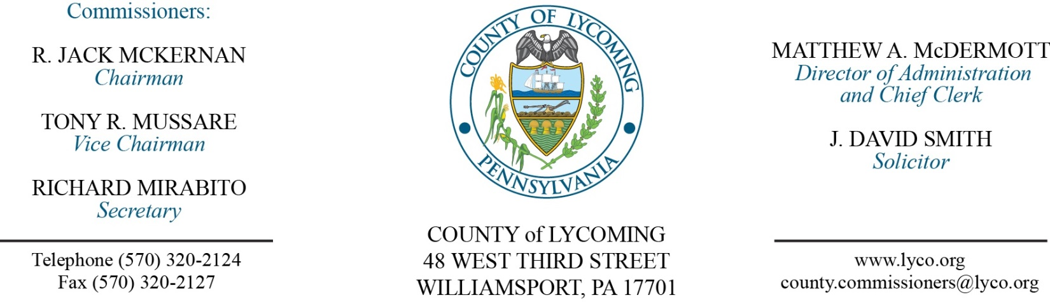
Commissioners’ Meeting Agenda
April 20, 2017

Opening Prayer

Pledge to the Flag

1.0 OPERATIONS

1.1 Convene Commissioners’ meeting.

1.2 Approve the minutes of the previous meetings.

1.3 Receive public comments (agenda items only).

2.0 ACTION ITEMS

2.1 Approve amendment to professional service agreement with PetroChoice. (Jason Yorks)

2.2 Approve amendment to professional service agreement with eLoop. (Jason Yorks)

2.3 Approve the following personnel actions:
Prothonotary – Sharon L. Greene as full time replacement Clerk III – Pay grade 4 - $13.95/hour effective 4/24/17.
Prothonotary – promotion of Brandy L. Lechette as full time replacement Clerk I – Pay grade 2 - $12.82/hour effective 4/23/17.
Prison – promotion of Jason C. Eiswerth as full time replacement Intake Officer – COII - $20.65/hour effective 5/7/17.
Prison – promotion of Stephen S. George as full time replacement Central Control Operator – COII - $24.0048/hour effective 5/7/17.
Prison – Andrea R. Hoover as full time replacement LPN – Pay grade 6 - $18.42/hour effective 5/8/17.
Prison – Ryan I. Kepner as full time replacement Correctional Officer Relief I – COI - $15.77/hour effective 4/30/17.

Reconvene Commissioners’ Meeting

5.0 REPORTS/INFORMATION ITEMS

5.1 In recognition of Earth Day (April 22, 2017), receive update on energy efficient County Facilities from Ken George and environmentally conscious items from Jason Yorks.

6.0 COMMISSIONER COMMENT:

7.0 PUBLIC COMMENT:

8.0 NEXT REGULARLY SCHEDULED MEETING: Planning Session on Tuesday, April 25, 2017.

9.0 ADJOURN COMMISSIONERS’ MEETING.

