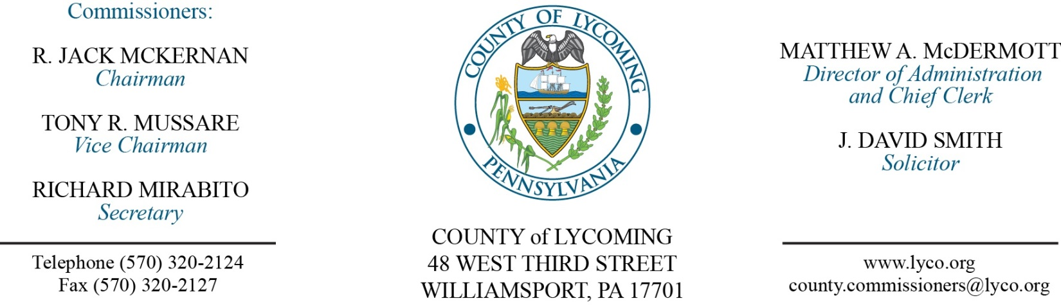
Commissioners’ Meeting Agenda
May 4, 2017

Opening Prayer

Pledge to the Flag

1.0 OPERATIONS

1.1 Convene Commissioners’ meeting.

1.2 Approve the minutes of the previous meetings.

1.3 Receive public comments (agenda items only).

2.0 ACTION ITEMS

2.1 Proclaim May 7-13, 2017, as corrections professionals week. (Kevin DeParlos)

2.2 Approve project modification request to PCCD Intermediate Punishment Program grant. (Jenn McConnell)

2.3 Approve memorandum of understanding with IPPC Technologies, Inc. for Cyber Supervision training in the amount of $600. (Ed McCoy)

2.4 Approve professional service agreement with Water Works Transport LLC. (Marci Hessert)

2.5 Approve the following purchases totaling $80,950: (Beth Johnston)
• Toro 300 gallon sprayer from Finch Services, Inc. in the amount of $30,000 (PA state contract).
• (2) Pro Gator heavy duty utility carts from Finch Services, Inc. in the amount of $30,000.00 (PA state contract).
• (3) TX gator light duty utility carts from Finch Services, Inc. in the amount of $4.000 (PA state contract).
• Landpride seeder from Jamco Products in the amount of $6,955.
• Purchase of Soil Reliever deep tine aerifier from Jamco Products in the amount of $9,995.

2.6 Approve update to TDA eliminating the temporary Veterans Affairs Assistant position. (Roxanne Grieco)

2.7 Accept Human Resources Report through April 30, 2017. (Roxanne Grieco)

2.8 Approve the following personnel actions: (Roxanne Grieco)
Conservation District – Sofia Luckenbill as part time West Nile Virus Technician – Pay grade 8 - $18.40/hour effective 5/8/17, not to exceed 1,000 hours annually.
Controller – promotion of Sherrie L. Hook as full time replacement Administrative Specialist – Pay grade 6 - $17.08/hour effective 6/4/17.
RMS – Resource Recovery – Gary O. Evans as full time replacement Truck Driver (Drop-off) – Pay grade 6 - $16.59/hour effective 5/8/17.1

Recess Commissioners’ Meeting

3.0 SALARY BOARD

3.1 Convene Salary Board.

3.2 Approve update to the salary schedule eliminating the temporary Veterans Affairs Assistant position.

3.3 Adjourn Salary Board.

Reconvene Commissioners’ Meeting

5.0 REPORTS/INFORMATION ITEMS

5.1 Lycoming County is requesting bids for food products for the 3rd quarter 2017. (Beth Johnston)

5.2 Recognize Jody L. Dietz on her retirement. (Kevin DeParlos)

6.0 COMMISSIONER COMMENT:

7.0 PUBLIC COMMENT:

8.0 NEXT REGULARLY SCHEDULED MEETING: Planning Session on Tuesday, May 9, 2017.

9.0 ADJOURN COMMISSIONERS’ MEETING.

