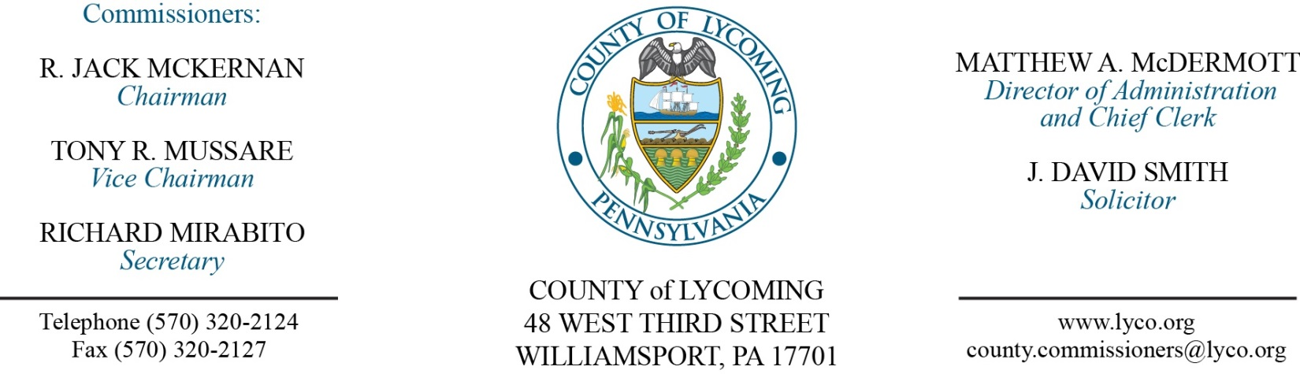
Commissioners’ Meeting Agenda
July 11, 2017

Opening Prayer

Pledge to the Flag

1.0 OPERATIONS

1.1 Convene Commissioners’ meeting.

1.2 Approve the minutes of the previous meetings.

1.3 Receive public comments (agenda items only).

1.4 Bid Opening: Lycoming County Bridge Repair (2nd bid) (11 bidders).

2.0 ACTION ITEMS

2.1 Approve accounts payable cash requirement report through July 21, 2017, for payment on July 14, 2017. (Beth Johnston)

2.2 Approve amendment to professional service agreement with Marks, McLaughlin & Dennehy for Mental Health Hearings. (Mya Toon)

2.3 Approve subrecipient monitoring contract with the James V. Brown Library for the Keystone Recreation, Park and Conservation Fund grant in the amount of $40,000. (Mya Toon)

2.4 Approve Williamsport Lycoming Community Fund grant application with First Community Foundation Partnership in the amount of $89,610. (Chris Ebner)

2.5 Approve professional service agreement with Enginuity-LY for cooling tower. (Ken George)

2.6 Approve professional service agreement with Barr Construction for PRC roof. (Ken George)

2.7 Approve change order from Port Elevator Inc. in the amount of $24,530. (Ken George)

2.8 Approve update to TDA - DPS Communications - full time Temporary Assistant Communications Specialist – Pay grade 9. (Roxanne Grieco)

2.9 Approve the following personnel actions: (Roxanne Grieco)
Pre-Release – Lisa M. Norton as full time replacement Female Resident Supervisor – Pay grade 5 - $15.22/hour effective 7/16/17.
Prison – Dustin C. Heiser as full time replacement Correctional Officer Relief – COI - $16.01/hour effective 7/31/17.
Information Services – Christopher B. Cooley as full time replacement Network Engineer – Pay grade 8 - $38,548.49/annually effective 7/31/17.
Sheriff – Ryan I. Kepner as full time replacement Deputy Sheriff– Pay grade 7 - $18.08/hour effective 8/13/17.
Sheriff – Stacey M. Lepley as full time replacement Deputy Sheriff– Pay grade 7 - $18.08/hour effective 7/17/17.
DPS Communications – promotion ofJacob E. Winter as full time replacement Telecommunicator II – Pay grade 8 - $20.67/hour effective 7/2/17.
DPS Communications – promotion of Scott W. Konkle as full time Temporary Assistant Communications Specialist – Pay grade 9 - $30.06/hour effective 7/16/17.

Recess Commissioners’ Meeting

3.0 SALARY BOARD

3.1 Convene Salary Board.

3.2 Approve update to the Salary Schedule: DPS Communications - full time Temporary Assistant Communications Specialist – Pay grade 9.

3.3 Adjourn Salary Board.

Reconvene Commissioners’ Meeting

5.0 REPORTS/INFORMATION ITEMS

5.1 The Lycoming County Commissioners/Department of Public Safety will be hosting a Lycoming County Fire Service Leadership / Local Government Symposium on Saturday, July 15 from 8:00 a.m. – 1200 noon at the Trade & Transit II Center. (John Yingling)

6.0 COMMISSIONER COMMENT:

7.0 PUBLIC COMMENT:

8.0 NEXT REGULARLY SCHEDULED MEETING: Planning Session on Tuesday, July 18, 2017. No meeting this Thursday, July 13.

9.0 ADJOURN COMMISSIONERS’ MEETING.

