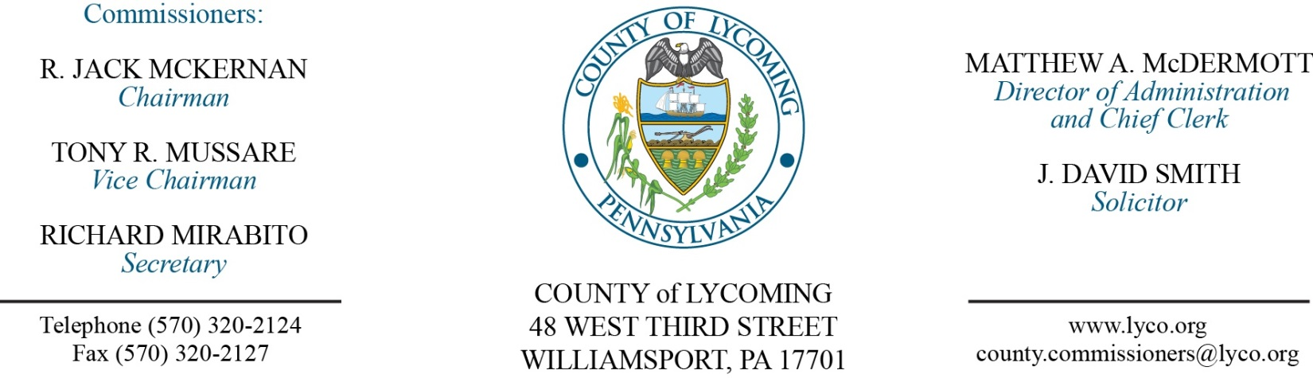
Commissioners’ Meeting Agenda
September 28, 2017

Opening Prayer

Pledge to the Flag

1.0 OPERATIONS

1.1 Convene Commissioners’ meeting.

1.2 Approve the minutes of the previous meetings.

1.3 Receive public comments (agenda items only).

2.0 ACTION ITEMS

2.1 Adopt resolutions 2017-22, 23, 24, 25 for extension of KOZ. (Jason Fink)

2.2 Approve grant application First Community Foundation Partnership of Pennsylvania in the amount of $4,790 for the Coroner’s office. (Mya Toon)

2.3 Award contracts for food items to the following on a per item as needed basis: (Mya Toon)
Keyco Distributors Benjamin Foods
Feesers, Inc Sysco Food Services LLC

2.4 Approve lease agreement for forensic center for a period of 60 months in the amount of $25,279.03/annually. (Mya Toon)

2.5 Approve lease agreement for MDJ Lepley through December 2021 in the amount of $1,917.13/month. (Mya Toon)

2.6 Approve agreement with Cummins Sales and Service, in the amount of $21,853.57. (Dave Bonus)

2.7 Approve 904 Recycling Performance Grant application. (Lauren Strausser)

2.8 Approve the following personnel actions: (Roxanne Grieco)
Courts – MDJ Frey – promotion of Deanna M. Roth to Full time replacement Clerk IV – Pay grade 5 – $17.55/hour effective 9/24/17.
Public Defender – Dance F. Drier as full time replacement Assistant Public Defender – Union - $52,250.56/annually effective 10/2/17.
Domestic Relations – reclassification of Greta L. Davis as full time Deputy Chief DRO – Pay grade 11 - $53,556.82/annually effective 10/8/17.
District Attorney – reclassification to full time replacement Assistant County Detective – NEU - $18.305/hour effective 10/22/17.
Coroner – Olivia A. Forney as part time replacement Deputy Coroner/On Call – Pay grade 7 - $16.83/hour effective 10/2/17, not to exceed 1,000 hours annually.
Coroner – Alysse R. Williams as part time replacement Deputy Coroner/On Call – Pay grade 7 - $16.83/hour effective 10/2/17, not to exceed 1,000 hours annually.

2.9 Accept the Human Resources Report through September 30, 2017. (Roxanne Grieco)

Recess Commissioners’ Meeting

4.0 BOARD of ASSESSMENT REVISION

4.1 Convene Board of Assessment Revision.

4.2 Approve the following real estate exonerations:
46-334-102.09 - Mark & Denise Gatsche - 70 Boston Cove Rd - -$86.94 -Duplicate Interim 2017.
23-337-137-007 - Blaine & Donna Brown - 1205 Mordan Hollow Rd Lt 7 -$211.26 -Trailer moved out of county 2016-2017.

4.3 Approve the following real estate exemption requests:
27-288-179 Quiggleville United Methodist Church 2119 W Rt 973 Hwy.
40-006-200 Muncy Creek Twp 170 W Water St.
15-004-107 Hepburn Township 457 Haleeka Rd.
43-004-100 Apostolic Pentecostal Church 2405 Bottle Run Rd.
18-168-117.02 Jackson Township Blockhouse Rd.
37-003-108 Muncy School District 227 Pepper St.
57-001-307.A Washington Township 15973 S Rt 44 Hwy.
39-001-408 Muncy Historical Soc Museum 296 N Market St.

4.4 Approve request for real estate refund:
41-352-111.20 - May Dept Stores - $2,275.11.

4.5 Deny request for real estate refund:
57-001-307.A – Washington Twp – $30.37.

4.6 Adjourn Board of Assessment Revision.

Reconvene Commissioners’ Meeting

5.0 REPORTS/INFORMATION ITEMS

5.1 Present JWD awards:
Agent Bryan Bower
Agent Adam Lorson

5.2 Present service awards:
10 years
Adam Gehr
20 years
Brad Shoemaker
Heather Klem
Bill MacInnis
30 years
Roni Kreisher

5.3 Lycoming County is requesting proposals for Muncy Resilience Plan.

6.0 COMMISSIONER COMMENT:

7.0 PUBLIC COMMENT:

8.0 NEXT REGULARLY SCHEDULED MEETING: Planning Session on Tuesday, October 3, 2017.

9.0 ADJOURN COMMISSIONERS’ MEETING.

