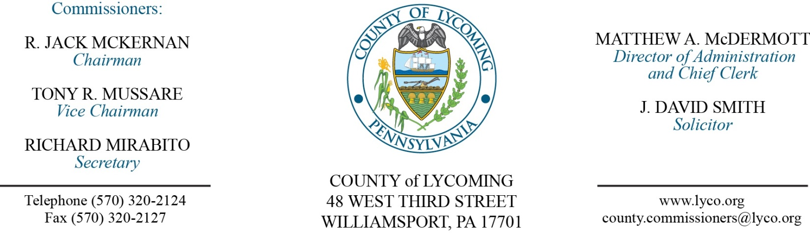
Commissioners’ Meeting Agenda
November 16, 2017

Opening Prayer

Pledge to the Flag

1.0 OPERATIONS

1.1 Convene Commissioners’ meeting.

1.2 Approve the minutes of the previous meetings.

1.3 Receive public comments (agenda items only).

2.0 ACTION ITEMS

2.1 Approve the following agreements with C&N: (Beth Johnston)
Fee agreement (Post Closure Fund).
Fee agreement.
C&N Investment Policy Statement (Post Closure Fund).
C&N Investment Policy Statement.
C&N Investment Policy Statement (Insurance Fund).

2.2 Award contract for bottled water service for RMS to Tulpehocken Mountain Spring Water, Inc. on an as needed per item basis. (Jason Yorks)

2.3 Approve quote from Productivity Products and Services, Inc dba Topcon Solutions Store for the annual Carlson Command Office software subscription in the amount of $2,995. (Jason Yorks)

2.4 Approve amendment 1 to agreement with Mahantango Enterprises, Inc, for tire recycling. (Jason Yorks)

2.5 Award sales agreement to Robert Losell in the amount of $35,300.00 for the 2007 Sterling Acterra PT-1000 20-Cubic Yard Packer Truck. (Jason Yorks)

2.6 Approve professional service agreement with the following for the Juvenile Probation Office: (Nancy Ackley)
Northampton County Youth Services Agency
Mid Atlantic Youth Services Glen Mills Clear Vision

2.7 Approve agreement for inmate housing with the following: (Mya Toon)
Clinton County Centre County.

2.8 Approve addendum to master agreement with Pyramid Communications for In-vehicle repeaters. (Mya Toon)

2.9 Approve bills of sale for the following vehicles that were auctioned on Municibid:
2008 Ford Explorer sold for $1,000.00 to David Columbine.
2002 Ford E350 Van sold for $1,850.00 to Michael Greco.
1999 Chevrolet Tahoe sold for $1380.00 to Larry Mullen.
Snow Blower sold for $111.00 to Randy Knipe.

2.10 Approve amendment to agreement with WBRA for Rt15 Corridor Sanitary Sewer. (Josh Billings)

2.11 Approve the following personnel actions: (Roxanne Grieco)
Fiscal Services – Karen F. Wright as part time Clerk III – Pay grade 4 - $13.756557/hour effective 11/19/17, not to exceed 1,000 hours annually.
Sheriff – reclassification of Jennifer Hartley as full time replacement Clerk III – Pay grade 4 - $16.02/hour effective 11/19/17.
RMS – Operations – promotion of Randy Sandstrom as full time replacement Assistant Operations Manager – Pay grade 9 - $25.37/hour effective 11/19/17.
Pre Release – Tanya Hall as full time replacement Work Crew Foreman – Pay grade 8 - $19.81/hour effective 12/18/17.
Pre Release – Erin E. Frantz as part time replacement Resident Supervisor – Pay grade 5 - $14.14/hour effective 11/20/17, not to exceed 1,000 hours annually.

5.0 REPORTS/INFORMATION ITEMS

5.1 Lycoming County is requesting bids for Early Intervention Program. (Mya Toon)

5.2 Present JWD award to Paula Simpler.

5.3 Present 10 year service pin:
Jerry Kennedy Jr.

6.0 COMMISSIONER COMMENT:

7.0 PUBLIC COMMENT:

8.0 NEXT REGULARLY SCHEDULED MEETING: Planning Session on Tuesday, November 28, 2017. No meetings November 21 & 23. Happy Thanksgiving!

9.0 ADJOURN COMMISSIONERS’ MEETING.

