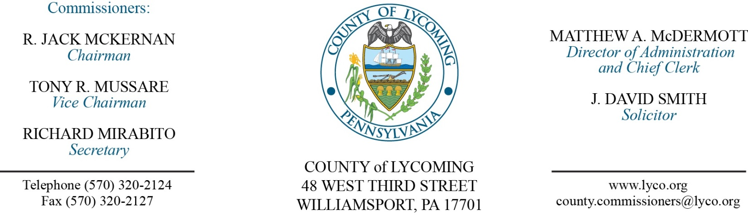
Commissioners’ Meeting Agenda
November 30, 2017

Opening Prayer

Pledge to the Flag

1.0 OPERATIONS

1.1 Convene Commissioners’ meeting.

1.2 Approve the minutes of the previous meetings.

1.3 Receive public comments (agenda items only).

Recess Commissioners’ Meeting

Public Hearing for CDBG OBO South Williamsport.
(Kristin McLaughlin)

Reconvene Commissioners’ Meeting

2.0 ACTION ITEMS

2.1 Approve FFY 2016 South Williamsport OBO agreement.
follows: (Kristin McLaughlin)
‐ Church Street Reconstruction $66,557.35
‐ Seventh Avenue Reconstruction $16,436.65
‐ Administration $18,210.00

2.2 Enact Ordinance 2017-04 for bond. (Joe Muscatello/Chris Brewer)

2.3 Award contract to Tetra Tech for Muncy Resilience Plan in the amount of $250,000. (Josh Schnitzlein)

2.4 Approve amendment to agreement with DNA Diagnostics Center Inc for parentage testing extending it to 12/31/2018. (Stephanie Tribble)

2.5 Approve amendment to agreement with Chaplain Andrew France extending it to 12/31/2018. (Mya Toon)

2.6 Approve professional service agreement with Penn College for Pre Release Center garage/shed. (Mya Toon)

2.7 Approve subrecipient monitoring agreement with Lycoming County United Way for the Homeless Assistance Program in the amount of $153,114. (Mya Toon)

2.8 Approve subrecipient monitoring agreement with STEP for MATP in the amount of $1,778,827. (Mya Toon)

2.9 Approve amendment to professional service agreement with Rogers Uniforms for correctional officers uniforms extending it to 12/31/2018. (Mya Toon)

2.10 Approve amendment to professional service agreement with West Branch D&A extending it to 12/31/2018. (Chris Ebner)

2.11 Approve grant agreement for FY 2017/2018 Hazardous Material Relief Fund in the amount of $17,961.33. (Darla Greiner)

2.12 Award contract for aggregate material to Glenn O. Hawbaker, Inc. in the amount of $1,018,140. (Jason Yorks)

2.13 Approve Field 12 air quality plan submission to DEP. (Jason Yorks)

2.14 Approve the following personnel actions:
Prison – Chelsia Snyder as full time replacement LPN – Pay grade 6 - $21.00/hour effective 12/5/17.
Sheriff – Roxanne N. Myers as full time replacement Clerk III – Pay grade 4 - $13.95/hour effective 12/3/17.
Veterans Affairs – reclassification of Frank J. Passaniti as full time Veterans Affairs Assistant – Pay grade 7 - $18.08/hour effective 12/3/17.

Recess Commissioners’ Meeting

4.0 BOARD of ASSESSMENT REVISION

4.1 Convene Board of Assessment Revision.

4.2 Approve real estate refund for parcel 26-329-171.A - Stephen Hensler in the amount of $479.65.

4.3 Adjourn Board of Assessment Revision.

Reconvene Commissioners’ Meeting

6.0 COMMISSIONER COMMENT:

7.0 PUBLIC COMMENT:

8.0 NEXT REGULARLY SCHEDULED MEETING: Planning Session on Tuesday, December 5, 2017.

9.0 ADJOURN COMMISSIONERS’ MEETING.

