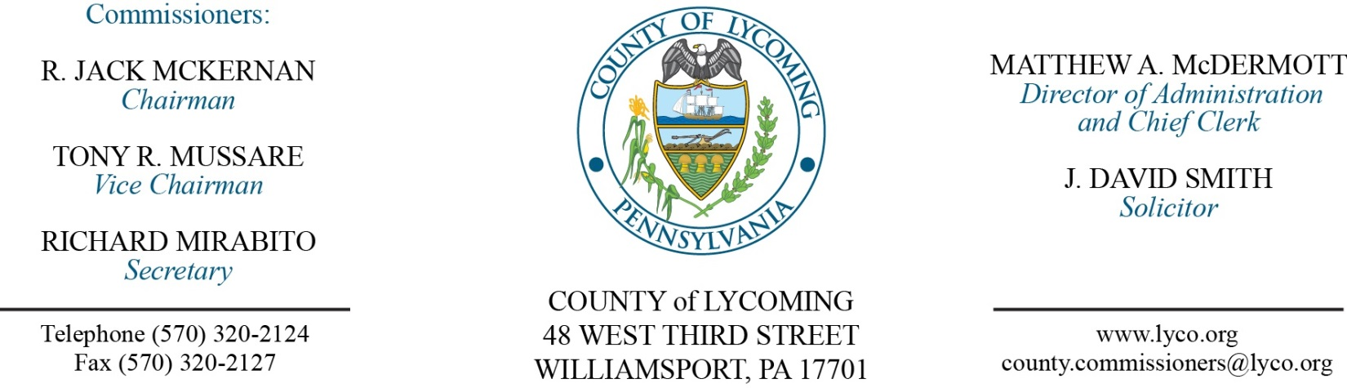
Commissioners’ Meeting Agenda
December 7 , 2017

Opening Prayer

Pledge to the Flag

1.0 OPERATIONS

1.1 Convene Commissioners’ meeting.

1.2 Approve the minutes of the previous meetings.

1.3 Receive public comments (agenda items only).

2.0 ACTION ITEMS

2.1 Adopt resolution 2017-31 for the five year capital plan.

2.2 Adopt resolution 2017-32 for the 2018 budget.

2.3 Adopt resolution 2017-33 setting the 2018 millage rate.

2.4 Adopt resolution 2017-34 setting the predetermined ratio.

2.5 Approve accounts payable cash requirement report through December 13, 2017, for payment on December 6, 2017. (Beth Johnston)

2.6 Approve invoice from Teleosoft for court scheduling software in the amount of $11,264. (Jerry Kennedy)

2.7 Approve invoice from Teleosoft for sheriff system software in the amount of $18,109. (Jerry Kennedy)

2.8 Approve invoice from Teleosoft for orphans court software in the amount of $12,875. (Jerry Kennedy)

2.9 Approve third extension to the Inter-County Cooperative communications agreement with Sullivan County. (John Yingling)

2.10 Approve the following personnel actions: (Roxanne Grieco)
DPS - Jeffrey W. Arnold, Jr. as full time replacement Telecommunicator I/WOE – Pay grade 6 - $16.59/hour effective 12/11/17.

2.11 Approve personnel action report through November 30, 2017. (Lauren Bower)

5.0 REPORTS/INFORMATION ITEMS

5.1 Lycoming County Resource Management Services is requesting bids for lubrication products. (Jason Yorks)

6.0 COMMISSIONER COMMENT:

7.0 PUBLIC COMMENT:

8.0 NEXT REGULARLY SCHEDULED MEETING: Planning Session on Tuesday, December 12, 2017.

9.0 ADJOURN COMMISSIONERS’ MEETING.

