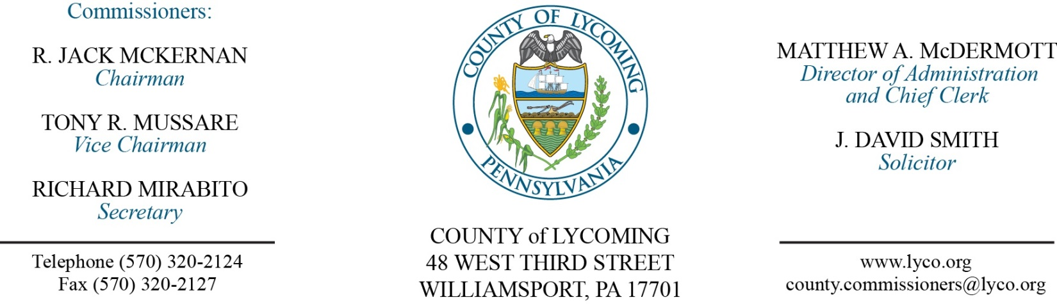
Commissioners’ Meeting Agenda
January 25, 2018

Opening Prayer

Pledge to the Flag

1.0 OPERATIONS

1.1 Convene Commissioners’ meeting.

1.2 Approve the minutes of the previous meetings.

1.3 Receive public comments (agenda items only).

2.0 ACTION ITEMS

2.1 Adopt resolution 2018-01 for $40,000 donation. (Mark Murawski)

2.2 Approve amendment to agreement with Bill Anskis Company for county bridge 113 repairs. (Mark Murawski)

2.3 Approve amendment 2 to agreement with Larson Design Group for county bridge 111/113 repairs. (Mark Murawski)

2.4 Approve submission of Hazardous Materials Emergency Response Preparedness Annual Report to PEMA. (Darla Greiner)

2.5 Award contract for lubrication products to Petrochoice on a per item as needed basis. (Jason Yorks)

2.6 Approve purchase from QED Environmental Services, Inc., for 1- New 2018 GEM5000 Portable Gas Extraction Monitor and accessories in the amount of $11,570. (Jason Yorks)

2.7 Approve update to TDA: RMS – reclassify the Business Manager pay grade 10/11 to Comptroller/Business Manager pay grade 13; Domestic Relations – reclassify 2 Clerk I (II) positions pay grade 2/3 to Clerk III paygrade 4; Information Services – reclassify Network Engineer pay grade 8/9 to Senior Network Engineer pay grade 9/10. (Ann Gehret)

2.8 Approve the following personnel actions: (AnnGehret)
Veterans Affairs – reclassification of Frank J. Passaniti as full time Veterans Affairs Assistant – Pay grade 7 - $18.08/hour effective 10/16/17.
RMS – Resource Recovery – Gary O. Evans as full time replacement Shipping Clerk – Pay grade 6 - $17.007239/hour effective 1/28/18.
RMS – Business Office – Steven M. Simms as full time replacement Comptroller/Business Manager – Pay grade 13 - $90,000/annually effective 2/5/18.
Information Services – reclassification of Alix N. Hoover as full time Senior Network Engineer – Pay grade 10 - $48,278.26/annually effective 1/28/18.
Domestic Relations – reclassification of Erika N. Young as full time Clerk III – Pay grade 4 - $13.95/hour effective 1/28/18.
Domestic Relations – reclassification of Julie A. Ault as full time Clerk III – Pay grade 4 - $13.95/hour effective 1/28/18.
Pre-Release – Jeffrey A. Horn as full time replacement Resident Supervisor – Pay grade 6 - $23.83/hour effective 1/28/18.

2.9 Award contract to Perform Reentry Services.

Recess Commissioners’ Meeting

3.0 SALARY BOARD

3.1 Convene Salary Board.

3.2 Approve update to the 2018 Salary Schedule - Elected officials salaries; Domestic Relations – 2 Clerk III positions salary; Information Services – Senior Network Engineer salary.

3.3 Approve update to the 2018 Salary Schedule -RMS - Comptroller/Business Manager salary.

3.4 Adjourn Salary Board.

Reconvene Commissioners’ Meeting

5.0 REPORTS/INFORMATION ITEMS

5.1 Present JWD awards to Prison staff. (Kevin Deparlos)

5.2 Present the following service pins:
10 years
Melissa Kalaus District Attorney.
Amy Fry PCD.
Jonathan Foster PRC.
Darla Greiner DPS.
Joe Kyle Maintenance.
20 years
Becky Steppe Prison.

6.0 COMMISSIONER COMMENT:

7.0 PUBLIC COMMENT:

8.0 NEXT REGULARLY SCHEDULED MEETING: Planning Session on Tuesday, January 30, 2018.

9.0 ADJOURN COMMISSIONERS’ MEETING.

