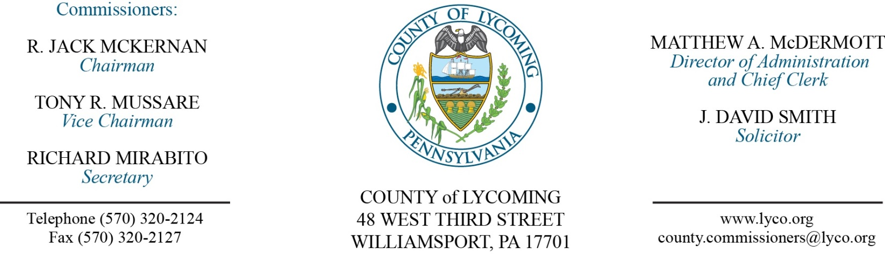
Commissioners’ Meeting Agenda
March 1, 2018

Opening Prayer

Pledge to the Flag

1.0 OPERATIONS

1.1 Convene Commissioners’ meeting.

1.2 Approve the minutes of the previous meetings.

1.3 Receive public comments (agenda items only).

2.0 ACTION ITEMS

2.1 Approve professional service agreement with Dr. Pat Bruno for the District Attorney’s office. (Mya Toon)

2.2 Approve Bill of Sale for the following lots that were auctioned on Municibid: (Mya Toon)
- Best Unity 1 8KVA UPS sold for $56.00 to David Searles.
- Miscellaneous Lot 3 sold for $150.00 to Toni Taylor.

2.3 Approve professional service agreement with Palmetto Posting for the collections office. (Tom Heap)

2.4 Approve TDA changes for RMS Reorganization: DETAILS TO COME.

2.5 Approve the following personnel actions: (Lauren Bower)
RMS – Resource Recovery – Joseph Strausser as full time replacement Truck Driver – Pay grade 5 - $15.22/hour effective 3/5/18.
RMS Reorganization Personnel actions.

2.6 Accept HR report through February 28, 2018. (Lauren Bower)

2.7 Approve accounts payable cash requirement report through March 14, 2018, for payment on March 7, 2018, pending review and approval by commissioners. (Beth Johnston)

2.8 Approve purchase of flags from Flagzone LLC in the amount of $10,576.80. (George Heiges)

Recess Commissioners’ Meeting

3.0 SALARY BOARD

3.1 Convene Salary Board

3.2 Approve update to the salary schedule:
RMS Reorganization.

3.3 Adjourn Salary Board.

Reconvene Commissioners’ Meeting

5.0 REPORTS/INFORMATION ITEMS

5.1 Present JWD awards (2). (Karl Demi)

5.2 CAFR presentation.

5.3 Comp Plan presentation (Fragmentation). (Kim Wheeler)

6.0 COMMISSIONER COMMENT:

7.0 PUBLIC COMMENT:

8.0 NEXT REGULARLY SCHEDULED MEETING: Planning Session on Tuesday, March 6, 2018.

9.0 ADJOURN COMMISSIONERS’ MEETING.

