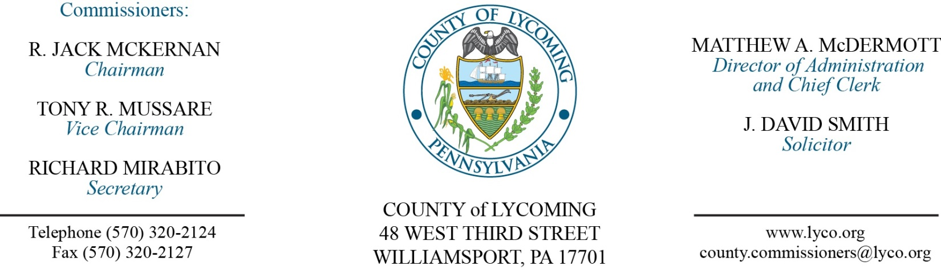
Commissioners’ Meeting Agenda
April 12, 2018

Opening Prayer

Pledge to the Flag

1.0 OPERATIONS

1.1 Convene Commissioners’ meeting.

1.2 Approve the minutes of the previous meetings.

1.3 Receive public comments (agenda items only).

2.0 ACTION ITEMS

2.1 Award contracts for equipment tires and tire repair to McCarthy Tire Service and Service Tire Truck Centers on an as needed bases per bid item pricing. (Jason Yorks)

2.2 Approve amendment 1 to professional service agreement with Overhead Door Company. (Jason Yorks)

2.3 Approve amendment 2 to professional service agreement with Deacon Equipment Co. for Tub Grinder supplies. (Jason Yorks)

2.4 Approve Change Order Number-3 for the EPP gas system integration. (Jason Yorks)

2.5 Approve purchase of 2 - new 2018 Modine Heaters with related parts from APR Supply Company thru the PA Costars in the amount of $13,890.67. (Jason Yorks)

2.6 Approve VMWare Licensing and Support off of COSTARS quote from Arraya Solutions in the amount of $60,465.16. (Jerry Kennedy)

2.7 Approve Grant & Monitoring Agreement with Lycoming Police Camp Cadet Foundation Inc. in the amount of $3,000. (Mya Toon)

2.8 Approve Grant & Monitoring Agreement with Lycoming County Fire Police Association in the amount of $1,500. (Mya Toon)

2.9 Approve Grant & Monitoring Agreement with Lycoming County Senior Citizens in the amount of $10,000. (Mya Toon)

2.10 Approve professional service agreement with Cybergenetics for the District Attorney’s Office. (Mya Toon)

2.10 Approve the following personnel actions: (Roxanne Grieco)
Prison – promotion of Brad A. Shoemaker as full time replacement Warden – Pay grade 14 - $86,970.79/annually effective 4/22/18.
Prison – promotion of Timothy E. Stutzman as full time replacement Sergeant – Pay grade 9 - $25.75/annually effective 4/22/18.

Recess Commissioners’ Meeting

4.0 BOARD of ASSESSMENT REVISION

4.1 Convene Board of Assessment Revision.

4.2 Approve real estate refunds:
Casey & Brady Stopper - 71-012-862 – $4128.78.
Benjamin Stopper Jr - 71-004-232 – $3960.88.

4.3 Approve real estate exonerations:
71-012-862 | Casey & Brady Stopper | 2406 Reach Rd | 1975170 | 1268200
71-004-232 | Benjamin Stoppher Jr | 163 Catawissa Ave | 1759920 | 1081700
59-374-154.A-018 | Robert Hess | 52 Orchard Ave | 1970 | 0
40-374-169.B-015 | Tri Lateral Investment | 15 Heatherbrooke Est | 3740 | 0
57-410-125.A-001 | Matthew Miller & Rachel Beaver | 3269 Elimsport Rd | 11070 | 0
23-337-137-010 | Mike Robbins | 1205 Mordan Hollow Rd Lt 10 | 9980 | 0
39-001-503 | Muncy Borough | 308 N Main St | 109980 | 0
15-001-204 | Hepburn Township | 326 W Creek Rd | 70700 | 0
34A-007-319 | Keith & Holly Webster | 408 Tule St | 105130 | 0
64-005-519 | Robert Henderson Jr | 408 W Edwin St | 55480 | 0

4.4 Adjourn Board of Assessment Revision.

Reconvene Commissioners’ Meeting

5.0 REPORTS/INFORMATION ITEMS

5.1 Lawshee Run. (Kurt Hausammann)

6.0 COMMISSIONER COMMENT:

7.0 PUBLIC COMMENT:

8.0 NEXT REGULARLY SCHEDULED MEETING: Regular Meeting on Tuesday, April 17, 2018.

9.0 ADJOURN COMMISSIONERS’ MEETING.

