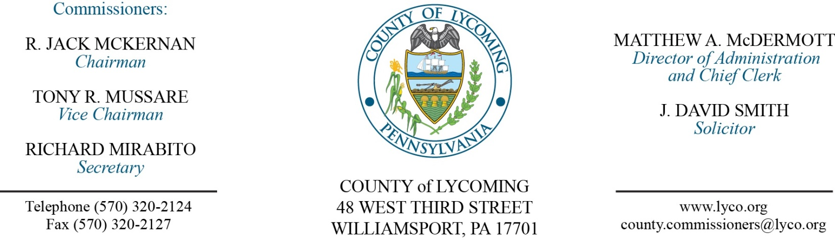
Commissioners’ Meeting Agenda
April 26, 2018

Opening Prayer

Pledge to the Flag

1.0 OPERATIONS

1.1 Convene Commissioners’ meeting.

1.2 Approve the minutes of the previous meetings.

1.3 Receive public comments (agenda items only).

Recess Commissioners’ Meeting

County Comprehensive Plan Public Hearing
(Kurt Hausammann/Kim Wheeler)

Reconvene Commissioners’ Meeting

2.0 ACTION ITEMS

2.1 Approve amendment to agreement with Lycoming Supply Inc for Lycoming County Bridge 111 repairs. (Mark Murawski)

2.2 Approve PHARE grant award in the amount of $400,000.00 from PHFA for Supportive Housing and Homes-In-Need. (Kim Wheeler)

2.3 Approve purchase of tasers and supplies in the amount of $15,201.00 from Axon Enterprises, Inc. (Mya Toon)

2.4 Approve grant and monitoring agreement with Firetree Place in the amount of $30,000. (Mya Toon)

2.5 Approve the following personnel actions: (Roxanne Grieco)
PCD – John E. Lavelle III as full time replacement Transportation Planner – Pay grade 9 - $54,455.19/annually, effective 5/6/18.
Public Defender – reclassification of Brittany Ohnmeiss as full time paralegal – Pay grade 7 - $18.43/hour effective 5/6/18.
Prison – Sean M. Winter as full time replacement Correctional Officer Relief – COI - $16.01/hour effective 4/29/18.
Prison – Brandon Taijeron as full time replacement Correctional Officer Relief – COI - $16.01/hour effective 4/29/18.
Prison – Tyler J. Feist as full time replacement Correctional Officer Relief – COI - $16.01/hour effective 4/29/18.
Prison – promotion of Ryan C. Barnes as full time replacement Deputy Warden/Operations & Security – Pay grade 12 - $55,366.91/annually effective 5/6/18.

2.6 Appoint Jason Fink to the Lycoming County Industrial Development Authority for a five year term ending 12/31/22.

5.0 REPORTS/INFORMATION ITEMS

5.1 Earth Day. (Lauren Strausser)

6.0 COMMISSIONER COMMENT:

7.0 PUBLIC COMMENT:

8.0 NEXT REGULARLY SCHEDULED MEETING: Planning Session on Tuesday, May 1, 2018.

9.0 ADJOURN COMMISSIONERS’ MEETING.

