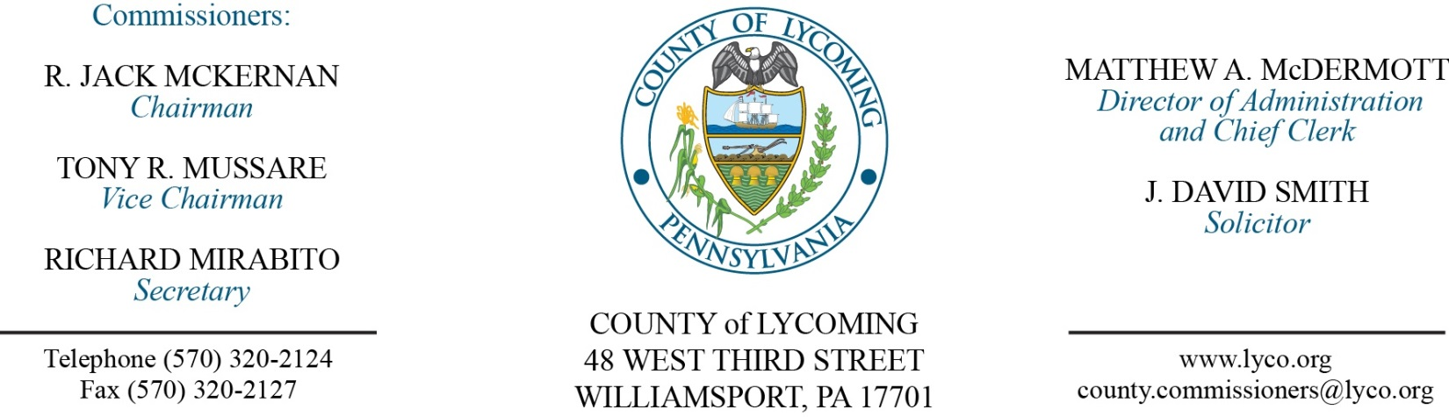
Commissioners’ Meeting Agenda
May 24, 2018

Opening Prayer

Pledge to the Flag

1.0 OPERATIONS

1.1 Convene Commissioners’ meeting.

1.2 Approve the minutes of the previous meetings.

1.3 Receive public comments (agenda items only).

2.0 ACTION ITEMS

2.1 Proclaim May as Drug Court Month in Lycoming County. (President Judge Butts)

2.2 Proclaim May 20-26 as EMS week in Lycoming County. (Wendy Hastings)

2.3 Adopt resolution 2018-14 for PIB loan application. (Mark Murawski)

2.4 Approve amendment to subrecipient agreement for 2014 CDBG with STEP. (Jenny Picciano)

2.5 Approve Letter of Intent with Rakestraw for sale of real estate. (Joshua Billings)

2.6 Approve Letter of Intent with Kmetz for sale of real estate. (Joshua Billings)

2.7 Approve child welfare services contract with KidsPeace National Centers, Inc. for foster care and residential care services at per diems ranging from $55.19/day to $333.08/day for the period July 1, 2017 through June 30, 2018. (Mark Egly)

2.8 Approve child welfare services contract with Second Haven Services for Youth for residential care services at a per diem of $224.45/day for the period July 1, 2017 through June 30, 2018. (Mark Egly)

2.9 Approve amendment to the 2017-18 child welfare services contract with Adelphoi Village, Inc. to reduce the per diem for two categories of foster care and residential care services for the period July 1, 2017 through June 30, 2018. (Mark Egly)

2.10 Approve Water Obstruction & Encroachment permit to PA DEP. (Michael Hnatin)

2.11 Approve plan extension request to DEP for Field 12. (Michael Hnatin)

2.12 Approve amendment to professional service agreement with ALS Environmental. (Michael Hnatin)

2.13 Approve amendment to professional service agreement with Highway Equipment & Supply Company Inc. (Michael Hnatin)

2.14 Appoint Trisha Marty to the Lycoming County Authority with term ending 12/31/22.

2.15 Approve update to TDA: Courts - Creation of an entry level Law Clerk Position; PCD – Elimination of the Environmental Planner position and reclassification of the Community Development/Lead Planner position. (Roxane Grieco)

2.16 Approve the following personnel actions: (Roxane Grieco)
Veterans Affairs – Michael D. Seitzer as full time replacement Veterans Affairs Assistant – Pay grade 6 - $16.59/hour effective 5/29/18.
Information Services – reclassification of Jerry L. Kennedy, Jr. as full time Deputy Director/Manager Networking & Systems – Pay grade 12 - $77,680.31/annually effective 6/3/18.
Maintenance – Nakisha J. Cramer as full time replacement Custodial Worker – Pay grade 1 - $10.84/hour effective 5/29/18.
PCD – reclassification of Jennifer A. Picciano as full time Community Development/Lead Planner – Pay grade 11 - $53,478.35/annually effective 6/3/18.
PCD – promotion of Thomas E. Krajewski as full time Development Services Supervisor – Pay grade 9 - $44,017.40/annually effective 6/3/18.
PCD – promotion of Austin J. Daily as full time Community & Economic Development Planner – Pay grade 8 - $39,794.80/annually effective 6/3/18.
PCD – reclassification of Joshua A. Billings as full time Subdivision and Land Development Administrator – Pay grade 8 - $55,570.64/annually effective 6/3/18.
RMS – Operations – reclassification of Nathaniel Edkin as full time Equipment Operator – Pay grade 6 - $18.00/hour effective 6/3/18.
RMS – Operations – Daniel P. Eck as full time replacement Equipment Operator – Pay grade 6 - $18.00/hour effective 5/31/18.
Courts – promotion of Amanda K. Bess as full time replacement Clerk IV – Pay grade 5 - $15.73/hour effective 6/17/18.
Prison – promotion of Bradley W. Baysore as full time replacement Corrections Counselor – Pay grade 9 - $21.62/hour effective 6/3/18.
Prison – Stephanie R. Hamilton as full time replacement Correctional Officer/Cook – COI - $16.01/hour effective 6/17/18.
Prison – Tyler P. Amos as full time replacement Correctional Officer Relief – COI - $16.01/hour effective 5/27/18.
Prison – Joseph W. Fullerton as full time replacement Correctional Officer Relief – COI - $16.01/hour effective 5/27/18.
District Attorney – Neil T. Devlin as full time replacement Assistant District Attorney – ADA - $52,764.08/annually effective 6/4/18.
District Attorney – Calvin R. Irvin as full time replacement Assistant Detective – AD - $19.234944/hour effective 6/3/18.

Recess Commissioners’ Meeting

3.0 SALARY BOARD

3.1 Convene Salary Board.

3.2 Approve update to salary schedule: Courts - Creation of an entry level Law Clerk Position; PCD – Elimination of the Environmental Planner position and reclassification of the Community Development/Lead Planner position.

3.3 Adjourn Salary Board.

6.0 COMMISSIONER COMMENT:

7.0 PUBLIC COMMENT:

8.0 NEXT REGULARLY SCHEDULED MEETING: Planning Session on Tuesday, May 29, 2018.

9.0 ADJOURN COMMISSIONERS’ MEETING.

