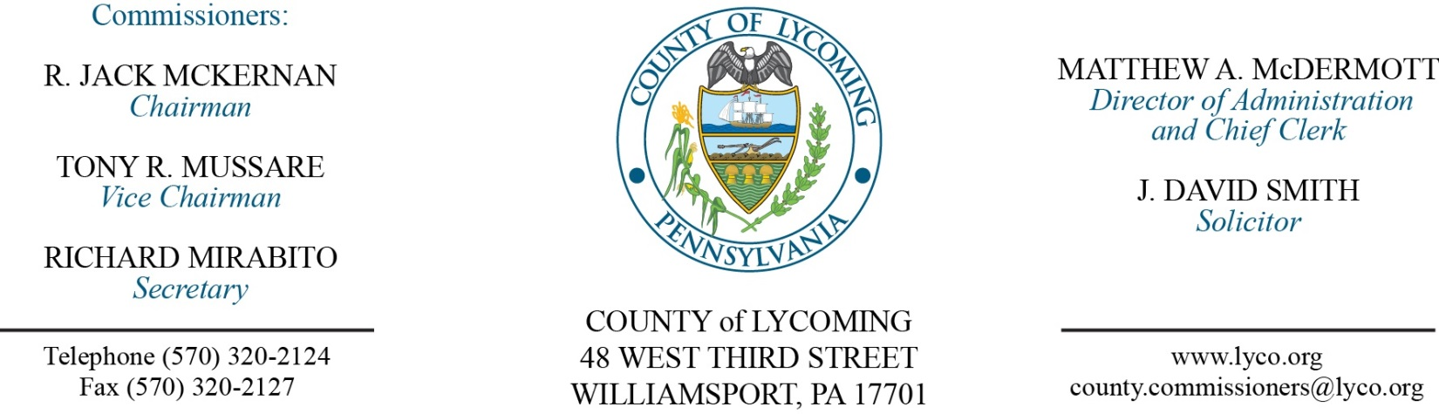
Commissioners’ Meeting Agenda
June 14, 2018

Opening Prayer

Pledge to the Flag

1.0 OPERATIONS

1.1 Convene Commissioners’ meeting.

1.2 Approve the minutes of the previous meetings.

1.3 Receive public comments (agenda items only).

2.0 ACTION ITEMS

2.1 Approve the following Act 13 Legacy Grants: (Kim Wheeler)
East Lycoming Recreation | Electrify Lime Buff Park Facilities | 15,000
Hepburn Township | Mutchler Park Playground Updates | 10,000
Loyalstock Township Board of Supervisors | Wading Pool | 10,000
Muncy Area Pool Association | 5 Yr. Capital Improvement Plan/Filtration system | 5,000
Muncy Creek Township | Kiess Park Pavillion Upgrades | 11,370
Muncy Historical Society | Cpt John Brady Heritage Park | 5,000
Newberry Little League | Reinvestment 2018 | 20,000
Nippenose Valley Little League | Nippenose School Fields Multi-Purpose Field Upgrade | 6,000
Piatt Township Supervisor | Ballfield Revitalization | 10,000
Rider Park, First Community Foundation Partnership of PA | Rider Park Educational Signage | 9,000
South Williamsport Community Park Improvement Assoc. | Community Park Tennis Project | 20,000
Way's Garden Commission | Historic Way's Garden Restoration | 20,000
Williamsport Municipal Water Authority | Pavilion & Picnic Shelter, Waterdale Environmental Education Center | 10,000
Nippenose Twp. | Antes Fort Village Park Trail | 10,000

2.2 Approve accounts payable cash requirement report through June 27, 2018 for payment on June 20, 2018 upon review and approval by Commissioners.

2.3 Award contract for bread products to Bimbo Bakeries. (Mya Toon)

2.4 Award contracts for food products on a per item as needed basis to the following: Keyco Distributors, Benjamin Foods, Sysco Food Services, LLC, and Feesers, Inc. (Mya Toon)

2.5Approve purchase from Eagle Equipment Corporation for 5- New 2018 Recycling Containers in the amount of $38,692.50. (Mya Toon)

2.6 Award contracts for HDPE Pipe items and Gas Well Accessories and Portable Gas Extraction Monitor as follows: (Mya Toon)
Bid Price Schedule A to Core & Main in the amount of $128,481.12
Bid Price Schedule B to QED Environmental Systems, Inc. in the amount of $2,904.60
Bid Price Schedule C to QED Environmental Systems, Inc. in the amount of $11,944.10.

2.7 Approve renewal of Full Court licensing used in the Prothonotary’s office in the amount of $11,825. (Karl Demi)

2.8 Approve the following personnel actions: (Roxanne Grieco)
Commissioners – Tonya R. Anderson as full time replacement Executive Secretary – Pay grade 5 - $29,679.54/annually effective 6/18/18.
District Attorney – full time replacement Assistant County Detective (NEU) – AD - $21.98/hour effective 6/24/18.

2.9 Approve professional service agreement with Hunter & Lomison for PRC generator not to exceed $76,410. (Ken George)

2.10 Reappoint David McKernan to SEDA CoG Board of Trustees with term expiration 4/28/21.

2.11 Reappoint Bob Moore to the Board of Assessment Appeals with term expiration of 12/31/21.

5.0 REPORTS/INFORMATION ITEMS

5.1 Karl Demi - Present JWD awards to the following:
Voters Services Staff
Forrest Lehman Jill Shuman
Mary Kay Camp Susan Johnson
IS Staff
Leslie Kilpatrick
Maintenance Staff
Ken George Dennis Straub
DPS Staff
John Yingling Kelle Robinson

6.0 COMMISSIONER COMMENT:

7.0 PUBLIC COMMENT:

8.0 NEXT REGULARLY SCHEDULED MEETING: Planning Session on Tuesday, June 26, 2018. No meetings June 19 or June 21.

9.0 ADJOURN COMMISSIONERS’ MEETING.

