Family Reunification
- Purpose
The Family Reunification Protocol is used to ensure a safe and secure means of accounting for students and reuniting parents/guardians with their children whenever the school facility or grounds is rendered unsafe and a remote site is needed.
If any District building must be evacuated for an extended period, students and staff members may have to relocate themselves, or when prudent to do so, be safely transported by bus to a designated parent-student reunification center. Parents will be informed of the reunification location through the district’s notification system. Once at the reunification center, students will be released to their parents/guardians according to District reunification procedures.
- Scope
This policy applies to all students, staff, parents, and emergency support providers of the School District. Other policies that may apply are Communications, Evacuation, Public Information, and Accountability.
The district has mutual aid agreements (MAA) or memorandums of understanding (MOA) in place with several alternate locations to ensure the safety and security of students, faculty, and staff. In the event students are evacuated and transported to a reunification site parents/guardian will be notified via phone, email, and text messaging.
- Situation
There are a wide variety of emergency situations that might require student/parent reunification. Student/parent reunification may be needed if the school site is evacuated or closed because of hazards discussed in the Hazard Analysis Summary of the schools’ Basic Plan.
The following reunification sites have been identified and memorandums of understanding obtained and provided separately.

Name of Facility | Physical Address | Contact Name/Alternate | Phone Number

- Assumptions
- Some parents will refuse to cooperate with the student/parent reunification process.
- Parents may be emotional when arriving at the school.
- While some emergency situations are slow to develop, others occur without warning. Hence, there may be little time for deliberate student/parent reunification. In fast moving incidents, student/parent reunification will be conducted with minimal preparation time. In the case of short notice, there may be little time to obtain personnel and equipment from external sources to support reunification operations.
- Persons other than those on the student’s emergency release form will try to pick up students during an emergency.
- Some parents or guardians will arrive without the needed forms or documentation.
- Reunification of some children with their parent or guardian may take longer than expected.
- Depending on the hazard, reunification can take place inside the school building, outside the school building, or at a distant site.
- Concept of Operations
- General
- In planning for student/parent reunification, the characteristics of the hazard and its magnitude, intensity, speed of onset, and anticipated duration are all significant factors. These causational factors will determine size, scope, and complexity of the reunification process.
- The school/district must be prepared to conduct both small-scale and large-scale reunification at all times of the day both from known hazard areas and from unexpected incident locations.
- Reunification staff including team leaders and the site coordinator may be staffed by existing school staff such as officer personnel, district level personnel, school nurse, Intermediate Unit personnel, and/or contracted mental health personnel, etc.
- The school/district will use a multistage system. Student/Parent Reunification Team members will be located in the following areas:
- The first area, the “student holding area,” will be where students will wait for their parents.
- The second area, “parent check-in,” is where parents will arrive to be reunited with the student, this is where staff ensure proper vetting takes place. Vetted parents are then escorted to a “parent holding area.”
- This final area is where staff will then separately escort the student and the parent from holding to reunite them in the “reunification area” for release.
- Student Holding Area Operations – Designated classroom teachers will remain with their assigned students in the holding area. Each will have the list of the students assigned to their supervision, including the exact name of their parents. Anyone who was absent at the start of the school day or who departed prior to the incident will be noted.
- Parent Check-in Operations – When a parent arrives, they will be asked for the name of the student being picked up. The parent will then be required to show proof of their identification (driver’s license or other government issued photo identification). When the staff member confirms the parent identity and authority to pick up the student, the staff member will use a runner or a radio/cellular telephone to notify the student holding area that the designated student is to be escorted to the reunification area. When the student and parent reports to the reunification area, the staff member will have the parent/guardian sign for the student on Student Release Form. Then the student will be released to the parent.
- If the child has been hospitalized or is deceased, staff will not indicate the status of the child but will escort the parent to the mental health counseling area. The “mental health counseling area” will be staffed by counselors and/or others trained in death notifications.
- Mental Health Counseling Area – Counselors and/or death notification trained persons will be responsible for notifying parents that their child is not available for pick-up for any of the following reasons: injured, dead, arrested, witness, etc. The staff member will:
- Provide available information regarding the child in a sensitive way.
- Will assure the parent that everything possible is being done to safeguard their child or their child’s remains.
- Will inform the parent who to contact to obtain additional further information about how they will be reunited with their child or arrange release of the remains.
- Will assist the parent with their trauma.
- Will make available to parent a means of communicating with other family members and friends.
- Will protect the parent from media representatives.
- When necessary, staff will call those parents who have not picked up their child. If a parent cannot be reached, Children & Youth Social Services will be notified.
- Traffic Control
- The flow of traffic at the reunification site will be controlled by (a school-based law enforcement, local law enforcement, and fire police).
- Traffic routing must allow for continued access by emergency vehicles.
- Where time permits, traffic control devices, such as signs and barricades, may be provided through County Emergency Management or by Municipal Road Maintenance.
- The need to clear disabled/illegally parked vehicles by wrecker services will be directed to SRO/Law enforcement.
- When reunification takes place at the established primary and secondary sites, see Attached “Traffic Access Control Plan.”
- Warning & Public Information
- Parent, guardian, and public warning or notification will take place as detailed in the Communications Annex.
- Access Control & Security
- During reunification, the security of the reunification site is extremely important.
- Staff and students shall be protected and kept safe.
- The Student/Parent Reunification Team, School-based Law enforcement, or local law enforcement should establish access control points to limit unauthorized access.
- Reunification site security is obtained and maintained via multilayers of control. Elements of this multilayered control include:
- Upon arrival at site, conduct a security sweep of the exterior and interior to ensure the scene is safe.
- Activate site-specific Traffic-Access Control Plan.
- Monitor, maintain, and refine access control and security measures as needed.
- In the event the primary or secondary reunification sites become unusable, obtain and adapt a site-specific Traffic-Access Control Plan for use at the improvised site.
- Action by Phases of Emergency Management
  - Mitigation
- Where possible, undertake mitigation for known hazards that have in the past led to situations requiring reunification.
- Seek improvement to preplanned holding areas if needed.
- Enhance warning systems to increase warning times and reduce the need for hasty evacuations.
  - Preparedness
- Identify primary and alternate reunification staff and team leaders.
- Prepare reunification staff through training, drills and exercises.
- Identify primary and secondary reunification sites and prepare facility layouts, traffic /access control plans, and public information and communications plans.
- Obtain memorandum of understandings for the use of the facilities.
- Prepare notification message templates to parents and the public. (See Public Information Policy)
- Send letters home to parents at the beginning of the school year to describe the reunification process.
- Prepare reunification kits and identify storage location and maintenance schedule.
  - Response
- Setup and staff family reunification center.
- Prepare for the arrival of parents.
- Check documentation to release students to parents.
- Reunite families
- Inform families of missing, injured or loss of student.
- Provide mental health and counseling support to families and teachers.
  - Recovery
- Return building to pre-reunification condition.
- Take photos or make notes of any damages to property.
- Coordinate temporary supervision for those whose parents or guardians cannot be contacted.
- If needed, provide transportation to those who can return to school for vehicles or require transportation home, such as school staff.
- Continue public information updates to parents and the media.
- Organization and Assignment of Responsibilities
- General
- The Superintendent has the general responsibility for recommending evacuation or school closure, when that is the most suitable means of protecting the staff and student from a hazard.
- The Building Principal/Incident Commander has the authority to recommend protective actions for their school building when deemed necessary.
- The hazard situation which gave rise to the need for reunification should be continually monitored in case changing circumstances, such as an increase in rainfall or wind shift change the potential impact area and, thus the area that is being used for reunification.
- School Incident Commander/Principal
- After consulting with an emergency Incident Commander (police, fire or other emergency official), if applicable, determine the appropriate pre-designated relocation site(s).
- The School Principal in most cases will not be at the Reunification Site, but remain at the school as part of the Unified Command with Emergency Services
- Designate a Reunification Site Commander.
- Ensure PIO keeps media informed of media briefing locations.
- Follow pre-determined parental notification procedures such as phone trees, local media channels, automated alert system, cell or text messaging, etc.
- Reunification Site
- Reunification Site Coordinator
- Acts as the “Incident Commander” of the Family Reunification Center
- Establish a reunification site as provided by the Incident Commander.
- Follow pre-determined procedures for releasing students.
- Request the District Office to send personnel to staff the reunification site(s).
- Notify a contact person at the relocation site(s) to prepare for arrival of students.
- Ensure all staff must wear badges/vests at all times
- Check identification of all non-uniformed personnel who arrive to assist.
- Identify reunification staff team leaders for major functional areas to include: Welcome Staff Team Leader, Parent Check-in Staff Team Leader, and Student Holding Area Operations Team Leader. Mental Health Counseling Area Team Leader, Family Reunification Area Team Leader. Provide briefings on their role and responsibilities.
- Provide periodic briefings to parents in holding area.
- Welcome Site Team Leader
- Supervise and review instructions with welcome staff describing their role.
- All parents picking up students must show ID.
- Parents may only sign out their own child.
- Prior to parents reaching the Parent Check-in Operation Area, welcome staff should provide the following information:
- Provide parent with a letter describing the reunification process.
- Explain the parent will need a photo identification and will need to be on the emergency release form that identifies who can pick up their child.
- Provide a release form to complete.
- Direct parents to appropriate line for parent check-in.
- Calm waiting parents/guardians and explain that an orderly process is required for the safety of the students.
- Parent Check-in Team Leader (Reception Staff)
- Supervise and review instructions with parent check-in staff describing their process and procedures.
- Using school binders, receive parents according to alphabet, school, or grade.
- Receive form from parents and check photo identification.
- Check school emergency release form on who can pick up student.
- Have individual previously identified on school emergency release form sign release form.
- Request parent to report to Parent Holding Area.
- Continue to receive updates on student status/accountability.
- Student Holding Area Team Leader
- Verify all student holding areas have been perused for safety.
- Provide escort to arriving teachers and students to their specific holding area.
- Provide support to teachers, as needed.
- Provide door signs to identify students (classroom, grade levels, etc.) in each holding area.
- Mental Health Counseling Team Leader
- Provide information to counselors about status of the emergency which caused evacuation and the need for family reunification.
- Assign staff to inform and counsel parents about their student status:
- Missing student
- Identified as a witness
- Status Unknown
- Injured student
- Death of a student
- Arrested student
- Minor Medical Treatment Team Leader
- Ensure the provision of basic first aid to students at family reunification center, as necessary.
- If student’s medical needs are greater than what can be provided, make arrangements to have student delivered to the appropriate health care facility.
- Ensure student medications are administered, as needed.
- Reunification Team Leader
- Supervise family reunification process.
- Ensure room is set up with chairs for families to be reunited.
- Ensure families are escorted to mental health area, if requested.
- Once reunited, have families escorted to building exit.
- Operations Team Leader
Ensures that the runners, teachers/aids, office staff, facility custodians, and emergency services have the necessary equipment and manages issues as they arise. Supervises the tasks of the Family Reunification Center Staff
  - Runners
- Receive briefing from Reunification Site Coordinator.
- Escort parents, students and families to their destinations, as assigned.
  - Teachers/Aids
- Provide a list of evacuated students to the reunification site staff upon arrival.
- Ensure special needs students and staff are assisted.
- Assign tasks to teacher aides, as needed
- Request help if needed.
- Provide supervision to assigned students.
- Follow the instructions of the Reunification Site Coordinator and/or assist in staffing the site.
  - Office Staff
- Provide all attendance records for the day.
- Provide list of students absent or who have left school for the day.
  - Facility-Custodians (at reunification site)
- Using stanchion, gates or traffic cones block off all areas not used for family reunification
- Put signs on exterior doors to direct parents to entrance area.
- Assist reunification staff in setting up reunification areas.
  - Law Enforcement (at reunification site)
- Limit access to all external/internal areas of the school.
- Provide traffic control on roadways, if needed
- Provide law enforcement, as needed.
  - Fire/EMS
- Responsible for fire protection at the reunification site.
- Assist in removing disabled and other special needs students as needed.
- Assist Nurse, as necessary, in attending to students with minor injuries.
- Provide traffic and access control to the building and parking area.
- Maintain building capacity.
Attachments:
- Reunification Center Organizational Chart
- Reunification Process
- Reunification Site Recommended Equipment
- Student Release Form
- Traffic Pattern Design of Reunification Sites.
Family Reunification Center Organizational Chart
May not be at the Family Reunification Center, but remaineding the school as part of Unified Command

Reunification Process
PARENTS
STUDENTS
The following graphic outlines the reunification process for staff.

Successful
Reunification
Parent Check-In – Parent is checked to confirm they are authorized to take custody of the student
Welcome Area – Provide “Welcome” letter and “Student Release Form” to parent.
- Must have Photo ID
- Must be listed on Student Authorization
Parent Arrives at Reunification Site
Students Arrive at Reunification Site
- Rosters are checked
- Student Area Team Leader notified the Parent Check-In & Mental health & Counseling Team Leaders of missing students.
Students will remain in the holding area until notified
No parents are permitted to enter the Family Reunification Center until all areas have reported that they are ready and the Reunification Site Coordiantor announces to open the Site
Reunification Area –
Once the parent is moved to Parent Holding, the Parent Check-In Team Leader requests the Student Holding team Leader to have the student escorted to the Family Reunification Area. Once the student has arrived, the Family Reunification Team Leader sends a runner to escort the parent to the Reunification Area
YES

Parent Holding – Parent is escorted to the Holding Area until their student is ready
NO
NO
Mental Health & Counseling – After a parent whose student is missing is moved to the Parent Holding Area, the Check-In Team Leader shall contact the Mental Health & Counseling Team Leader so that Mental Health & Counseling can attend to the parent.
Is the Student listed as “missing?”
Verification Area – Parent is escorted to the Verification Area where it can be determined if the adult is authorized to take custody of the student.
YES

Reunification Site Recommended Equipment
NO. | ITEM
 | Position Job Descriptions
 | Clipboards
 | Vests/Colored Team shirts
 | Name Tags
 | Pens
 | Staplers
 | Markers
 | Notepads
 | Interior and Exterior Facility Layouts
 | Functional Needs Assistance Plans
 | Set up Instructions
 | Snacks
 | Water
 | Student Release Forms
 | Welcome Letters to Parents
 | Binders or Thumb drives with student information/authorization
 | Caution Tape
 | Duct Tape
 | Scotch Tape
 | Barricades/Stanchions
 | Folding tables
 | Folding chairs
 | Activity Log Forms
 | Laptops
 | Extension Cords
 | Power Strips
Weather Resistant Signs (for major functional areas and alphabet, grade level, school)
Portable radios with chargers/batteries
Bull Horns
Traffic Cones

FAMILY REUNIFICATION STUDENT RELEASE
Welcome, reunification is a process that protects both the safety of the student and provides for an accountable change of custody from the school to a recognized custodial parent, guardian, or other authorized person.
- Please make sure you have your government issued identification, with a photo, ready for the check in process.
- Fill out top portion of the Student Release form.
- After completing the form, please wait in the Check in area until staff are available to check you in. You must have the Student Release form and your identification available when it is your turn to check in.
- Once you are checked in, you will be relocated to the Parent Holding Area until a staff member is available to take you to the Reunification Area to meet with your student. Before leaving the Reunification Area with your student, you must provide staff the student release form.
Thank you for your patience and cooperation during the reunification process.
Please Print Legibly – Complete a Separate Form for Each Student

Student’s Name: __________________________________________________ Grade: _____________
Student’s Date of Birth: _________________________ Student’s School ID#: ____________________
Name of Person Requesting Student: _____________________________________________________
Requestor’s Driver’s License #: ___________________________________ State: _________________
(Photo ID is mandatory for student release. If you do not have a driver’s license, list another form of photo ID)
Relationship to Student: _____________________________________________________
Proof of Photo ID: (Yes) (No) Name Listed as Parent or Guardian: (Yes) (No)
Verified By: ______________________ Name Listed as Emergency Contact: (Yes) (No)
Proof of Photo ID: (Yes) (No) Released By:_________________________________________

Release Date: ______________________________
Parent Signature:
______________________________________________Date/Time______________________

SAMPLE REUNIFICATION CENTER
Parent/Student Flow
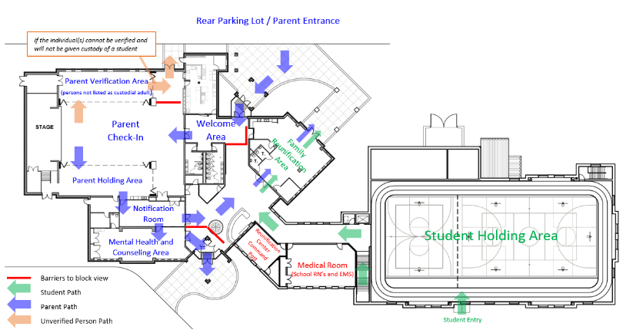
SAMPLE REUNIFICATION CENTER
Traffic Flow

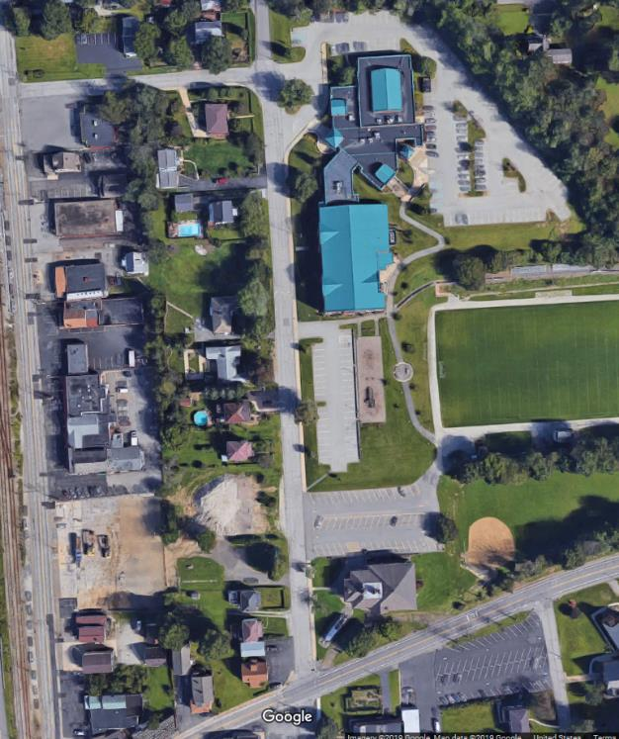

Parent Parking
Parent Overflow Parking
EMS/FD/PD Staging
Parent Overflow
Parking
+
Road Closed via Barricade
Student Entrance
Parent Entrance
Parent Route
Student/Bus Route
All Exiting Vehicles Route

