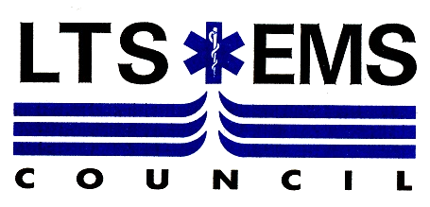

2021 REGIONAL PSYCHOMOTOR EXAMINATION SCHEDULE

Please visit the following Regions for further information regarding additional Psychomotor exams

Bucks County EMS Council https://www.buckscounty.gov/206/Emergency-Health-Services | EASTERN PA EMS COUNCIL http://www.easternemscouncil.org/ | Delaware County Regional EMS Council  http://board-members.pehsc.org/list/member/delaware-county-regional-ems-council-27 | Philadelphia Regional EMS  http://www.phila.gov/regionalems/Pages/default.aspx
Chester County - https://chescoems.org/bls-psychomotor-exams/ | EMS West  http://www.emsi.org/ | EMMCO WEST - https://emmco.org/education/regional-courses/ | MONTGOMERY COUNTY EMS COUNCIL https://www.emstrainingcenter.org/
Emergency Health Services Federation  http://www.ehsf.org/ | EMS of Northeastern Pennsylvania http://www.emsnp.org/home/index.html | SOUTHERN ALLEGHENIES EMS COUNCIL https://www.saems.com/psychomotor-exam-schedule | SEVEN MOUNTAINS EMS COUNCIL http://smemsc.org/

List Revised: 07/13/2021

Basic Life Support (BLS) for EMR, EMT & PHRN candidates

DATE | START TIME | LOCATION | # SEATS AVAILABLE | APPLICATION DEADLINE | CONTACT
12 August | 1730 | Lycoming County Department of Public Safety  542 County Farm Rd, Montoursville, PA 17754 | 20 | 05 August | LTSinfo@lyco.org
16 August  (retest) | 1730 | Lycoming County Department of Public Safety  542 County Farm Rd, Montoursville, PA 17754 | TBD | 12 August | LTSinfo@lyco.org

