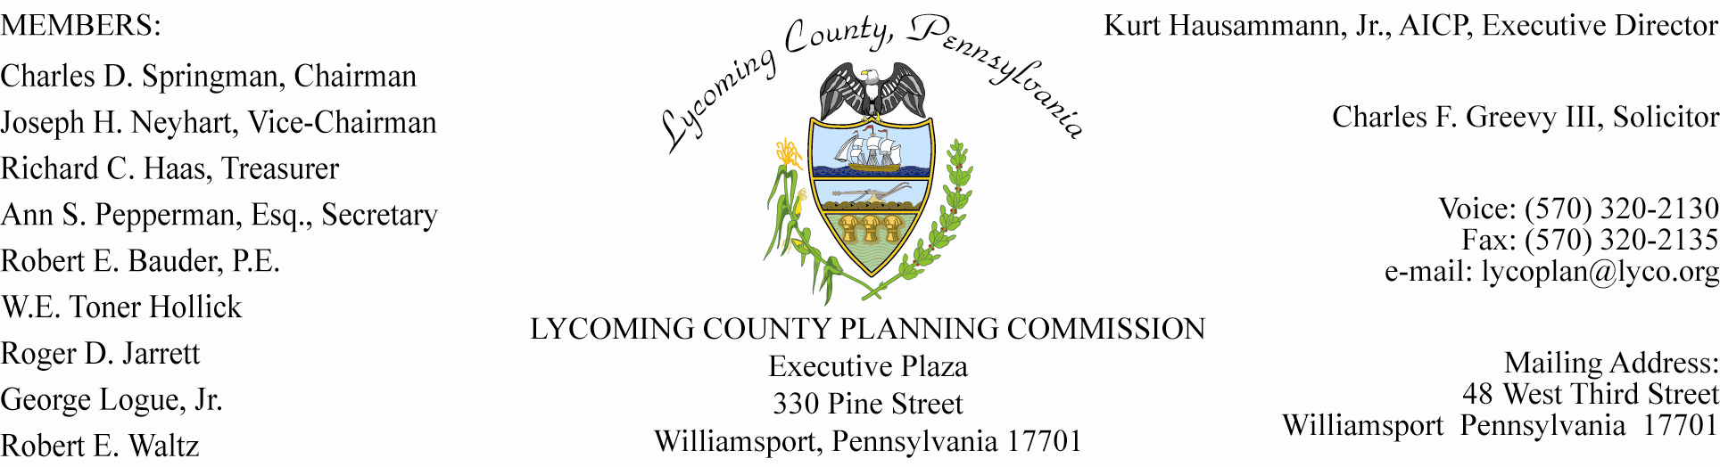

-INFORMATIONAL MEMO-

TO: Lycoming County Municipalities

FROM: Cliff Kanz, AICP, Development Services Supervisor,
Kurt Hausammann, Jr., AICP Director

DATE: May 19, 2008

SUBJECT: GAS DRILLING

At the request of the Director, of the County Planning & Community Development Department, we are contacting you with two items to consider. The two items would help address efforts to be informed of gas drilling in your community. Both are provided below as sample revisions or amendments to your existing Zoning Ordinance and Street Access Permitting Ordinance.

1. Zoning Ordinance Revision, where not already part of the ordinance.

Requiring gas drilling to obtain a temporary permit, helps to coordinate with other approving agencies of access permitting, State Department of Environmental Protection, and including sharing information within the community such as public water providers. Permitting the use in all districts during the temporary permit phase, likely does not conflict with the provisions of the PA Municipalities Planning Code.

SECTION TEMPORARY ZONING PERMIT REQUIRED

A temporary use shall be established with a Temporary Zoning Permit evidencing the compliance of such use with the provisions of applicable supplemental sections and other applicable provisions of this Ordinance shall have first been issued.

Memo To: Lycoming County Municipalities P. 2
Subject: Gas Drilling
Date: May 19, 2008

SECTION PERMITTED TEMPORARY USES

The following are temporary uses which are subject to specific regulations and standards as set forth below, in addition to the other requirements specified in this Ordinance.

Sub-section: Contractors Office, Watchman Trailers, Construction Equipment Sheds, Trailers

- Supplemental Controls

- Permitted in any district where the use is incidental to a construction project. Water and sanitary facilities shall be provided; sleeping and/or cooking accommodations may be provided.
- Permits shall be issued for one (1) year, and may be extended for additional periods until construction has ceased or has been completed.
- The temporary structure shall be removed from the property upon issuance of an Occupancy Permit for the new or rehabilitated building.

Sub-section: Oil and Gas Drilling

- Supplemental Controls

- Oil and gas drilling is permitted in all districts.
- The property owner or his/her agent shall submit a copy of a letter notifying the Municipality(s) Board of Supervisors prior to issuance of a Temporary Zoning Permit and commencement of the drilling operation.
- Upon receipt of a temporary use permit application, a processing fee, and the aforementioned letter, the Zoning officer, or his/her designee shall issue a temporary use permit placard for the drilling operation. The property owner or his agent shall conspicuously post this placard at the nearest point of public access.
- Revocation of any required Federal, State, Municipal, or other required approvals shall constitute an automatic revocation of the temporary Zoning Permit.
- The municipality may distribute the approved permit copies to other agencies on an as needed basis.

Memo To: Lycoming County Municipalities P. 3
Subject: Gas Drilling
Date: May 19, 2008

2. Ordinance Revision, to address road bonds, where not already in place.

Include criteria of road bonding by Gas drilling operators that are to be included with an access permit issued for entering/exiting Township roads. The bonding would be applied through the duration of the drilling. An initial step by the municipality is likely to be accessing the current condition of township roads. The roads to be used by the gas drilling operator would be part of the access permitting. From the routing, an estimate could be worked out between the municipality and the gas driller(s), to make eventual road repair with the bond fund, or by the road user(s.) Road users are referenced, due the roads that are travelled on by more than one well drilling operation, and their respective suppliers. In these cases, some sort of sharing of damages to roads would be open for discussion.

In summary, the above are very preliminary for your review and consideration. To proceed with adding some of the above items to your municipal ordinances should include your solicitor, and municipal consulting engineer. The importance is high, to address the community-wide impacts of the upcoming gas drilling through your land use controls. Time is of the essence. The drilling has begun in Lycoming County. It is only a matter of time until your municipality is affected.

