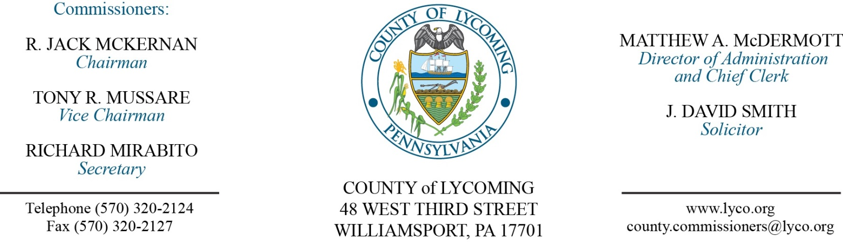
Commissioners’ Meeting Agenda
February 21, 2017

Opening Prayer

Pledge to the Flag

1.0 OPERATIONS

1.1 Convene Commissioners’ meeting.

1.2 Approve the minutes of the previous meeting.

1.3 Receive public comments (agenda items only).

2.0 ACTION ITEMS

2.1 Approve Sheriff Salary

Office | 2018 | 2019 | 2020 | 2021
Sheriff | $67,469.04 | $67,469.04 | $67,806.38 | $69,162.51

6.0 COMMISSIONER COMMENT:

7.0 PUBLIC COMMENT:

8.0 NEXT REGULARLY SCHEDULED MEETING: Planning Session on Thursday, February 23, 2017.

9.0 ADJOURN COMMISSIONERS’ MEETING.

