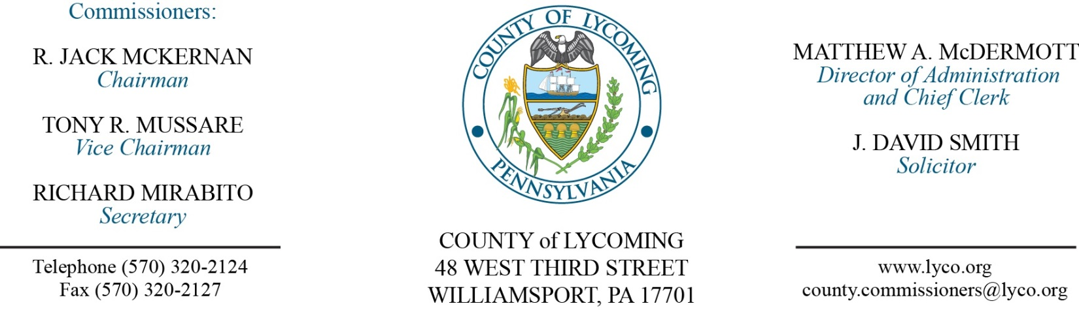
Commissioners’ Meeting Agenda
March 9, 2017

Opening Prayer

Pledge to the Flag

1.0 OPERATIONS

1.1 Convene Commissioners’ meeting.

1.2 Approve the minutes of the previous meetings.

1.3 Receive public comments (agenda items only).

2.0 ACTION ITEMS

2.1 Adopt resolution 2017-07 for the RACP grant for Muncy Hospital. (Dieter Reichmann)

2.2 Approve purchase of flags from Flagzone LLC in the amount of $10,576.80. (Mya Toon)

2.3 Approve professional service agreement with NMS Labs for the District Attorney’s office. (Mya Toon)

2.4 Approve payment to Daniel W. Burkhart in the amount of $51,260.00 for easement. (Mya Toon)

2.5 Approve amendment to professional service agreement with Cornell Abraxas Group, Inc. for Juvenile Probation. (Nancy Ackley)

2.6 Approve quote from Help Desk Technology Corporation for a 3 year renewal of software licensing and maintenance agreement for ServicePRO in the amount of $13,703.31. (Karl Demi)

2.7 Approve waiving disposal fees for waste collected during the Great American Cleanup days of PA from April 18 through and including May 9, 2017. (Jason Yorks)

2.8 Approve amendment 3 to agreement with WSP USA Corp for aerial photo mapping service. (Jason Yorks)

2.9 Approve drop off recycling service agreement with Monroe Township. (Jason Yorks)

2.10 Approve quote from Cummins Sales and Service, in the amount of $22,219.98. (Jason Yorks)

2.11 Approve grant receipt from PEMA for 911 statewide interconnectivity funds. (John Yingling)

2.12 Approve amendment to professional service agreement with Larson Design Group Inc for engineering services for Bridge #106. (Mark Murawski)

2.13 Approve the following personnel actions: (Roxanne Grieco)
Juvenile Probation – Mathew J. Stanzione as full time replacement Juvenile Probation Officer – Pay grade 8 - $19.61/hour effective 3/12/17.
Maintenance – Bionca M. Cardona as full time replacement Custodial Worker – Pay grade 1 - $10.84/hour effective 3/13/17.
Prison – Iesha Leatherbury-Glover as full time replacement LPN – pay grade 6 - $18.42/hour effective 3/20/17.

5.0 REPORTS/INFORMATION ITEMS

5.1 Lycoming County is requesting bids for custom crop farming. (Jason Yorks)

6.0 COMMISSIONER COMMENT:

7.0 PUBLIC COMMENT:

8.0 NEXT REGULARLY SCHEDULED MEETING: Planning Session on Tuesday, March 14, 2017.

9.0 ADJOURN COMMISSIONERS’ MEETING.

