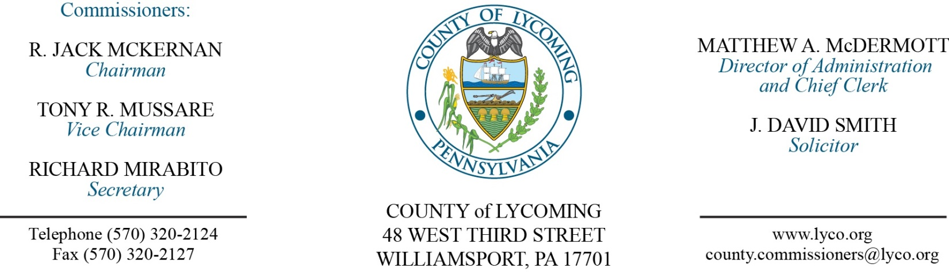
Commissioners’ Meeting Agenda
April 13, 2017

Opening Prayer

Pledge to the Flag

1.0 OPERATIONS

1.1 Convene Commissioners’ meeting.

1.2 Approve the minutes of the previous meetings.

1.3 Receive public comments (agenda items only).

2.0 ACTION ITEMS

2.1 Proclaim April 9-15 as Public Safety Telecommunications week in Lycoming County. (Sandy Holdren/John Yingling)

2.2 Proclaim April as Safe Digging Month. (Jason Yorks/Mark Lipka)

2.3 Adopt resolution 2017-10 for transfer of two vehicles. (Jason Yorks)

2.4 Award contract for custom crop farming to Matthew Baldwin in the amount of $1,321.11 annually for a period of five years. (Jason Yorks)

2.5 Approve quote from Highway Equipment & Supply Company for repair of skid steer in the amount of $13,764.79. (Jason Yorks)

2.6 Approve amendment to professional service agreement with Donald Martino, Esq for legal representation of Joe McCloskey. (Mya Toon)

2.7 Approve amendment to professional service agreement with Pearson Vue for Exhibit B - additional testing site at LCP. (Mya Toon)

2.8 Approve lease agreement with Lycoming County Housing Authority in the amount of $2,877 for a period of 36 months. (Mya Toon)

2.9 Approve professional service agreement with Cybergenetics for the District Attorney’s office. (Mya Toon)

2.10 Approve winning bids via Municibid auction below: (Mya Toon)
Richard Strushensky 2010 Chevrolet Equinox $5,000.00
Kevin Huber 2007 Chevrolet Impala $1,650.00
Peter Beltrami Western 8’ Snow Plow $ 500.00
Brian Farr Hobart Food Slicer $ 162.00
Toni Taylor Alto-Sham Warmer $ 51.00
Hugh Gross AeroHot Steamtable $ 165.00
Stephanie Tempesco Garland Double Oven $ 111.00
David Strayer Generac Generator $1,740.00

2.11 Approve grant and monitoring contract with the Community Arts Center in the amount of $75,000. (David Whitnak)

2.12 Award contract for fire suppression system to Suppression Systems Inc. in the amount of $149,900. (Ken George)

2.13 Approve update to TDA – Veterans’ Affairs – addition of temporary Veterans Affairs Assistant. (Roxanne Grieco)

2.14 Approve the following personnel actions: (Roxanne Grieco)
RMS-Engineering – Kaelyn M. Koser as full time replacement Environmental Technician – Pay grade 7 - $18.44/hour effective 4/23/17.
Veterans Affairs – Frank J. Passaniti as full time Veterans Affairs Assistant – Pay grade 6 - $16.59/hour effective 4/17/17.
Sheriff – Jordan C. Baier as full time replacement Deputy Sheriff – Pay grade 7 - $18.08/hour effective 5/7/17.
Pre-Release – Howard L. Williams as full time replacement Resident Supervisor/Cook – Pay grade 5 - $15.22/hour effective 4/24/17.
Pre-Release – Tiara Gough as full time replacement Resident Supervisor – Pay grade 5 - $15.22/hour effective 4/24/17.
Courts – Mandy Jo Myers as full time replacement Clerk III – Pay grade 4 - $13.95/hour effective 4/17/17.

Recess Commissioners’ Meeting

3.0 SALARY BOARD

3.1 Convene Salary Board.

3.2 Approve update to Salary Schedule to include the addition of temporary Veterans Affairs Assistant.

3.3 Adjourn Salary Board.

Reconvene Commissioners’ Meeting

5.0 REPORTS/INFORMATION ITEMS

5.1 Lycoming County is requesting bids for Re-Entry Service Center. (Mya Toon)

6.0 COMMISSIONER COMMENT:

7.0 PUBLIC COMMENT:

8.0 NEXT REGULARLY SCHEDULED MEETING: Planning Session on Tuesday, April 18, 2017.

9.0 ADJOURN COMMISSIONERS’ MEETING.

