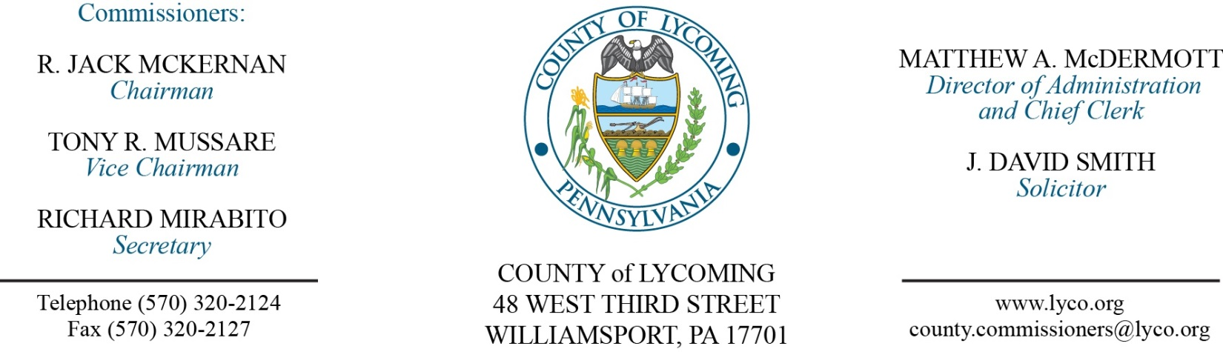
Commissioners’ Meeting Agenda
April 27, 2017

Opening Prayer

Pledge to the Flag

1.0 OPERATIONS

1.1 Convene Commissioners’ meeting.

1.2 Approve the minutes of the previous meetings.

1.3 Receive public comments (agenda items only).

2.0 ACTION ITEMS

2.1 Approve 2015 CDBG sub contract O.B.O. with Jersey Shore in the amount of $69,666. (Kristin McLaughlin)

2.2 Approve 2015 CDBG sub contract with Tiadaghton Valley Municipal Authority in the amount of $37,900. (Kristin McLaughlin)

2.3 Approve 2015 CDBG sub contract with Washington Township in the amount of $102,086. (Kristin McLaughlin)

2.4 Approve drop off recycling agreement with Union County. (Jason Yorks)

2.5 Approve drop off recycling agreement with Lewis Township, Northumberland County. (Jason Yorks)

2.6 Approve memorandum of understanding with the Housing Authority for environmental review for WODA/Muncy Green. (Merilyn Severson/Andy Cohen)

2.7 Approve grant and monitoring agreement for $10,000 with Lycoming County Senior Citizens Incorporated. (Mya Toon)

5.0 REPORTS/INFORMATION ITEMS

5.1 Lycoming County is requesting bids for Emergency Watershed Protection. (Mark Davidson/Mya Toon)

5.2 Lycoming County is requesting bids for inmate detention supplies & clothing for the prison and pre-release center. (Mya Toon)

5.3 Lycoming County is requesting bids to make needed repairs to Lycoming County Bridge No. 111 (Buttonwood Covered Bridge) and Lycoming County Bridge No. 113 (at English Center). (Mark Murawski)

6.0 COMMISSIONER COMMENT:

7.0 PUBLIC COMMENT:

8.0 NEXT REGULARLY SCHEDULED MEETING: Planning Session on Tuesday, May 2, 2017.

9.0 ADJOURN COMMISSIONERS’ MEETING.

