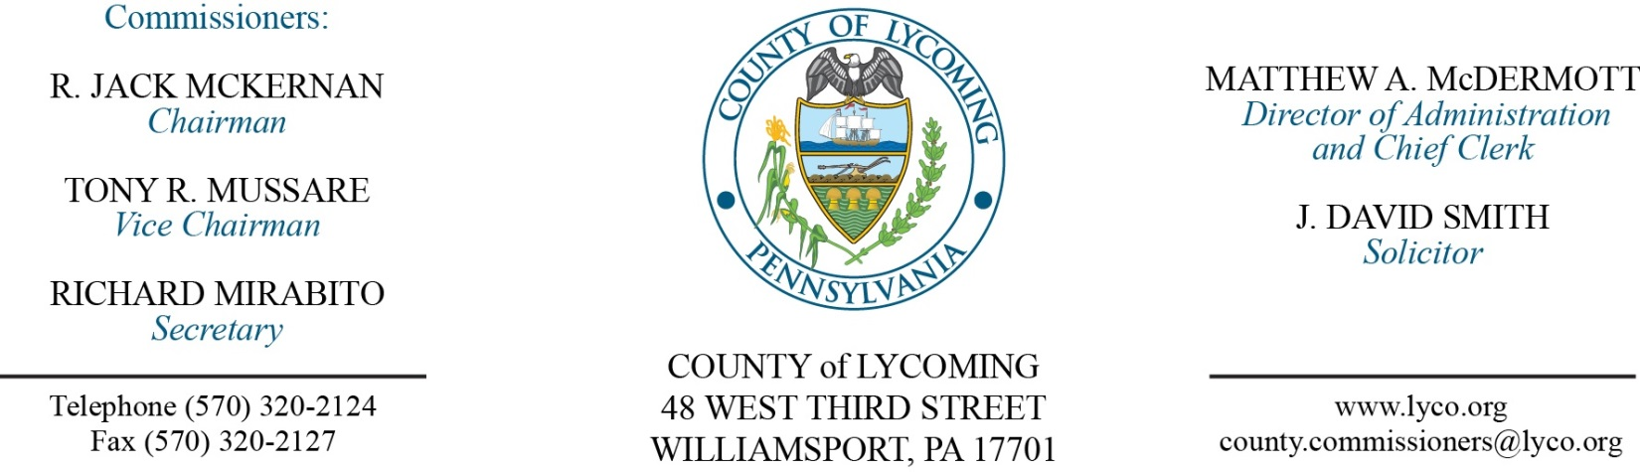
Commissioners’ Meeting Agenda
May 25, 2017

Opening Prayer

Pledge to the Flag

1.0 OPERATIONS

1.1 Convene Commissioners’ meeting.

1.2 Approve the minutes of the previous meetings.

1.3 Receive public comments (agenda items only).

2.0 ACTION ITEMS

2.1 Proclaim May 21-17, 2017, as EMS week in Lycoming County. (Donna Snyder)

2.2 Approve MCM Next Gen Radio System Needs Assessment. (John Yingling)

2.3 Adopt resolution 2017-14 for Greenways, Trails and Recreation Program grant application to the Commonwealth Financing Authority/DCED in the amount of $206,167. (Mark Murawski)

2.4 Reject bid received 5/23 for bridge repairs. (Mark Murawski)

2.5 Adopt resolution 2017-15 in connection with the Greg Township Municipal Authority Force Main Project. (Jason Yorks)

2.6 Approve professional service agreement with Sawyer Infrared. (Jason Yorks)

2.7 Approve submission of Compliance History Report to DEP. (Jason Yorks)

2.8 Award contract for Landfill Gas System to McClure Company in the amount of $1,219,995. (Jason Yorks)

2.7 Approve amendment 4 to professional service agreement with Palmetto Posting. (Tom Heap)

2.8 Approve amendment to professional service agreement with Jennifer McPherson for Re-Entry Coordinator. (Chris Ebner)

2.9 Approve Lycoming County Sheriff’s Office Repeater Project grant application receipt from Williams Atlantic Sunrise Project in the amount of $10,000. (Sheriff Lusk)

2.10 Award contracts for EWP as follows:
Insinger Excavating Inc. LY-16-02&03 in the amount of $113,740.00, Ly-16-05 in the amount of $19,450.00, and Ly-16-07 in the amount of $16,300.
Wolyniec Construction Inc. Ly-16-08 in the amount of $15,500.

2.11 Approve budget modification request for the Emergency Solutions Grant through DCED. (Mya Toon)

2.12 Approve PCoRP Risk Prevention Grant Application for 2016/2017 in the amount of $15,000. (Mya Toon)

2.13 Approve the following purchases totaling $80,950: (Mya Toon)
• Toro 300 gallon sprayer from Finch Services, Inc. in the amount of $30,000 (PA state contract).
• (2) Pro Gator heavy duty utility carts from Finch Services, Inc. in the amount of $30,000.00 (PA state contract).
• (3) TX gator light duty utility carts from Finch Services, Inc. in the amount of $4,000 (PA state contract).
• Landpride seeder from Jamco Products in the amount of $6,955.
• Soil Reliever deep tine aerifier from Jamco Products in the amount of $9,995.

2.14 Approve the following personnel actions: (Roxanne Grieco)
Treasurer – Promotion of Holly Bogart as full time replacement Clerk III – Pay grade 4 - $15.15/hour effective 6/4/2017.
Fiscal Services – Reclassification of Cynthia J. Gira as full time Fiscal Technician – Pay grade 6 - $16.59/hour effective 6/4/17.
PCD – Promotion of Jennifer A. Picciano as full time replacement Community Development /Lead Planner – Pay grade 10 - $47,423.97/annually effective 6/4/17.
Pre-Release – Jesica K. Hawkins as part time replacement Female Resident Supervisor – Pay grade 5 - $14.14/hour effective 5/29/17.
Correction to action on April 20, 2017: Prison –Stephen S. George as full time replacement Central Control Operator – COII - $22.1372/hour effective 5/7/17.

4.0 BOARD of ASSESSMENT REVISION

4.1 Convene Board of Assessment Revision.

4.2 Approve the following real estate refund requests:
29-171-106.B – David & Joanne Foy - $7.02.
06-211-102 – Melvin & Lisa Johnson - $420.91.

4.3 Approve the following real estate exoneration requests:
40-006-200 Muncy Creek Twp 170 W Water St Muncy.
49-003-700-001 James Wilson 324 Vilas Dr
41-001-112 James Crouse 500 Village Rd
07-392-104.A 4 Girton Dr LP 4 Girton Dr

4.4 Adjourn Board of Assessment Revision.

Reconvene Commissioners’ Meeting

5.0 REPORTS/INFORMATION ITEMS

5.1 Matt Schauer recognition (PA Wilds). (Kim Wheeler)

5.2 Introduction of the PA Wilds Executive Director, Ta Enos to receive PA Wilds update. (Kim Wheeler)

6.0 COMMISSIONER COMMENT:

7.0 PUBLIC COMMENT:

8.0 NEXT REGULARLY SCHEDULED MEETING: Planning Session on Tuesday, May 30, 2017.

9.0 ADJOURN COMMISSIONERS’ MEETING.

