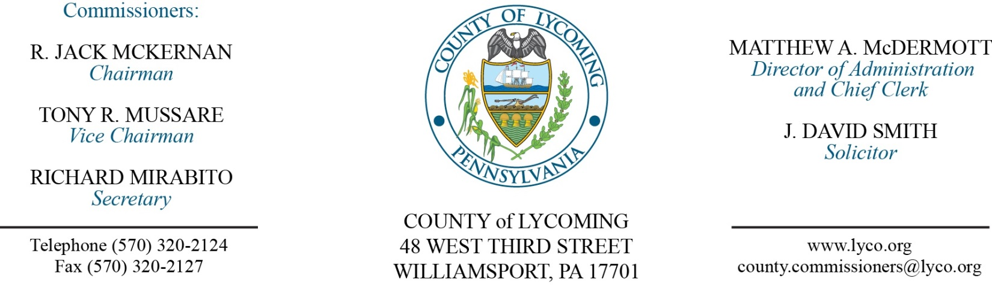
Commissioners’ Meeting Agenda
June 22, 2017

Opening Prayer

Pledge to the Flag

1.0 OPERATIONS

1.1 Convene Commissioners’ meeting.

1.2 Approve the minutes of the previous meetings.

1.3 Receive public comments (agenda items only).

2.0 ACTION ITEMS

2.1 Approve Lycoming County State Food Purchase Program Grant Agreement Participation Statement for Fiscal Year 2017-2018. (Eric Orndorff - Central PA Food Bank)

2.2 Approve amendment to professional service agreement with nCourt for online payment in Domestic Relations. (Paulette Clementoni)

2.3 Approve professional service agreement with Penn College for Fire & Safety Consulting Training 2017-2018. (Craig Konkle)

2.4 Approve amendment #1 to 2015 CECI professional service agreement with Civil & Environmental Consultants, Inc for evaluation of HDPE liner. (Jason Yorks)

2.5 Approve payment of in the amount of $21,125.73 to Loyalsock Township for recycling center paving project. (Jason Yorks)

2.6 Award contracts for surplus used recycling containers as follows: (Jason Yorks)
Lot Number-5: Douglas Millheim; highest bid price offered at $4,300.
Lot Number-6: Lardon Disposal; highest bid price offered at $4,000.
Lot Number-7: Lardon Disposal; highest bid price offered at $7,900.
Lot Number-8: Jon Yankelitis; highest bid price offered at $3,700.

2.6 Approve amendment #3 to professional service agreement with Brinjac Engineering for consulting engineer service. (Kurt Hausammann)

2.7 Approve amendment #2 to professional service agreement with Rettew Associates, Inc. for consulting engineer service. (Kurt Hausammann)

2.8 Approve amendment to professional service agreement with DEVNET for CAMA & wEdge software license 2017-2020. (Karl Demi)

2.9 Approve purchase of Iseries hardware and implementation from Sirius in the amount of $58,414.23 off of state contract. (Karl Demi)

2.10 Approve the following personnel actions: (Roxanne Grieco)
Information Services - Courtney English as full time replacement Assistant Printer – Pay grade 3 - $12.83/hour effective 6/26/17.

5.0 REPORTS/INFORMATION ITEMS

5.1 Lycoming County will be requesting bids for professional consulting engineering services. (Mya Toon)

5.2 Recognize Paulette Clementoni on her retirement. (President Judge Butts & Judge Anderson)

6.0 COMMISSIONER COMMENT:

7.0 PUBLIC COMMENT:

8.0 NEXT REGULARLY SCHEDULED MEETING: Planning Session on Tuesday, June 27, 2017.

9.0 ADJOURN COMMISSIONERS’ MEETING.

