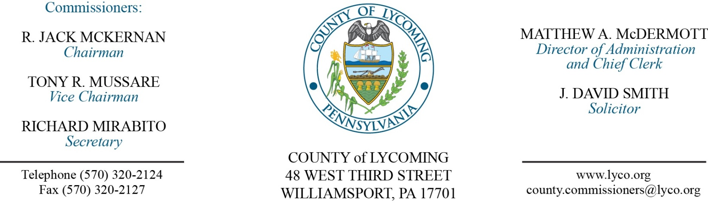
Commissioners’ Meeting Agenda
July 27, 2017

Opening Prayer

Pledge to the Flag

1.0 OPERATIONS

1.1 Convene Commissioners’ meeting.

1.2 Approve the minutes of the previous meetings.

1.3 Receive public comments (agenda items only).

2.0 ACTION ITEMS

2.1 Enact Ordinance 2017-03, UPI amendment.

2.2 Adopt resolution 2017-17 declaring property as surplus. (Mya Toon)

2.3 Adopt resolution 2017-18 declaring property as surplus. (Mya Toon)

2.4 Accept personnel action report through July 31, 2017. (Roxanne Grieco)

2.5 Approve the following personnel actions: (Roxanne Grieco)
Information Services – reclassification of Tjark D. Pengel as full time Program Analyst I – Pay grade 8 - $39,635.70/annually effective 7/30/17.
Domestic Relations – reclassification of Stephanie M. Tribble as full time Chief Domestic Relations Officer – Pay grade 12 - $71,604.55/annually effective 7/30/17

Recess Commissioners’ Meeting

3.0 SALARY BOARD

3.1 Convene Salary Board.

3.2 Approve the attached list of roving DUI patrols for the period 7/1/2017 through 12/31/2018.

3.3 Adjourn Salary Board.

Reconvene Commissioners’ Meeting

5.0 REPORTS/INFORMATION ITEMS

5.1 Lycoming County is requesting bids for food products - 4th quarter. (Mya Toon)

5.2 Present JWD for RSI Eve Allen. (Kevin DeParlos)

6.0 COMMISSIONER COMMENT:

7.0 PUBLIC COMMENT:

8.0 NEXT REGULARLY SCHEDULED MEETING: Planning Session on Tuesday, August 1, 2017.

9.0 ADJOURN COMMISSIONERS’ MEETING.

IN THE COURT OF COMMON PLEAS OF LYCOMING COUNTY, PENNSYLVANIA

COMMONWEALTH OF PENNSYLVANIA :
:
IN RE: SPECIAL COUNTY DETECTIVE : No. MD-5-2017
:
:

MOTION FOR APPROVAL OF SPECIAL COUNTY DETECTIVES

AND NOW, comes Eric R. Linhardt, Esquire, District Attorney for Lycoming County, and respectfully represents the following:
1. The Lycoming County Office of District Attorney is engaged in the investigation of criminal activities, including but not limited to the operation of Sobriety Checkpoints and DUI Roving Patrols.
2. The various Sobriety Checkpoints and DUI Roving Patrols will be located in Lycoming County, Pennsylvania.
3. Various members of the municipal police departments in Lycoming County will be participating in the Sobriety Checkpoints and the DUI Roving Patrols within the 2017-2018 calendar years.
4. It will be necessary for those individuals participating in the Sobriety Checkpoints and DUI Roving Patrols to have appropriate law enforcement authority to execute their duties.
5. Statutes of the Commonwealth of Pennsylvania permit the District Attorney and the Court of Common Pleas, with the approval of the Salary Board, to approve “Special County Detectives” for particular assignments as designated by the District Attorney.
6. The statutes of the Commonwealth imply that such appointments require court approval.
7. The individuals to be appointed as Special County Detectives for the particular and temporary assignment of working the Sobriety Checkpoints and DUI Roving Patrols for the time period of July 1, 2017 – December 31, 2018 are as follows:
A. Montoursville Borough Police Department – Jeff Gyurina; Jason Bentley; Bill Hagemeyer; Kurt Hockman; Marc Storms; Ronald Bachman; Chris Herb;
B. Lycoming County Sheriff’s Department – Jason Sparks; Matthew Kula; Andrea Brackbill; Jonathan Rachael; Adam Ross; Cody Barto; Luke Motter; Nicholas Labe; Tanner Troutman; Scott Lose; Christopher Warden; Michael Orwig;
C. Montgomery Borough Police Department – Ernest Delp, III; Laurence Wilcox, Jr.; Jeffrey Houseknecht; Jason Wertz; Angel McLaughlin; Nathan Moyer; Eric Winters; Kenneth Flewelling;
D. South Williamsport Police Department – Robert Hetner; James Taylor; Carl Finnerty; Devin Thompson; Michael Samar; William MacInnis; Jacob Summers; Cody Lepley;
E. Penn College Police Department – David Pletz; Matthew Jodun; Fletcher Farr; Justin Hakes; Charles O’Brien; Nathan Moyer;
F. Williamsport Bureau of Police – Mark Lindauer; Mark Sechrist; Jody Miller; Brian McGee; Andrew Stevens; Ryan Brague; Steven Helm; Justin Ottaviano; Richard Hofford; Laura Miller; Justin Geesey; Aaron Levan; Brittany Alexander; Eric Derr; Kristopher Caster; Zachary Geary; Michael Corter; Clinton Gardner; Benjamin Hitesman; Tyson Minier; Christopher Sausbury; and
G. Tiadaghton Valley Regional Police Department – Shawn Hummer; Nathan DeRemer; Chad Aldenderfer; Brian Fioretti; Michael Crawford; Kyle Fera; Jordan Mahosky; Justin Segura; Tyler Beirly; Joshua Klinger; Catherine Farr;
H. Hughesville Borough Police Department- Rod Smith; Andrew Boyer; Ryan Travelpiece;
I. Old Lycoming Township Police Department- Joseph Hope; Christopher Kriner; Jeffrey Hughes; Matthew McCormick; Robert Cochran; Kenneth Brown; Michael Engel; Robert Mausteller;
J. Muncy Borough Police Department- James Dorman; Anthony Oeler; David Williams; Larry Wilcox; Curt Laudenslager; Ernest Delp III; Kenneth Flewelling; Raymond Kontz;
K. Muncy Township Police Department-Chris McKibben; Bryann Bingaman; and
L. Duboistown Police Department- Norman Hager; Roy Snyder.
8. The aforementioned officers were approved by the Lycoming County Salary Board on July 27, 2017 as “Special County Detectives” for participation in Sobriety Checkpoints and DUI Roving Patrols, as evidenced by the Commissioners’ Meeting Agenda, Action 3.3 (attached hereto as “Attachment A).
WHEREFORE, the Attorney for the Commonwealth respectfully requests that this Honorable Court enter an Order to approve the appointment of the aforementioned individuals as “Special County Detectives” with approval of the Lycoming County Salary Board.

Respectfully submitted,

Eric R. Linhardt
Lycoming County District Attorney
Pa.Bar I.D. No. 59981
48 West Third Street
Williamsport, Pa 17701

cc: DA
Police Depts.

