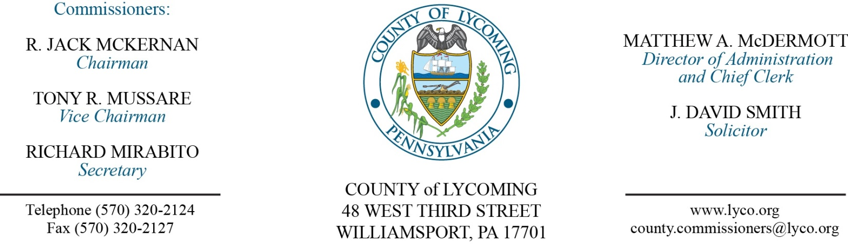
Commissioners’ Meeting Agenda
August 24, 2017

Opening Prayer

Pledge to the Flag

1.0 OPERATIONS

1.1 Convene Commissioners’ meeting.

1.2 Approve the minutes of the previous meetings.

1.3 Receive public comments (agenda items only).

2.0 ACTION ITEMS

2.1 Adopt resolution 2017-20 accepting donation. (Mya Toon)

2.2 Award contracts for surplus items as follows: (Mya Toon)
Multigraphics Paper Cutter to Toni Taylor in the amount of $61.
Pitney Bowes Mail Machine to Toni Taylor in the amount of $31.
Misc. Computer Equipment to Clyde Monahan in the amount of $797.
Misc. Computer Equipment to Clyde Monahan in the amount of $1,275.

2.3 Approve the following professional service agreements for the Juvenile Probation Department: (Nancy Ackley)
Justice Works.
Diakon.
Pa Treatment and Healing.
BSI.
C. Townsend Velkoff, M.S.
Cornell Abraxas Inc.

2.4 Approve annual license renewal with Equivant for Northpointe in the amount of $16,669.25. (Karl Demi)

2.5 Approve the following personnel actions: (Roxanne Grieco)
District Attorney – Kacey L. Prichard as part time replacement Clerk I – Pay grade 2 - $10.94/hour effective 9/6/17, not to exceed 1,000 hours annually.
Maintenance – Willie Terrell as full time replacement Custodial Worker – Pay grade 1 - $10.84/hour effective 9/11/17.
Public Defender – reclassification of Elisabeth D. Frankel as full time Paralegal – Pay grade 7 - $18.60/hour effective 8/27/17.

6.0 COMMISSIONER COMMENT:

7.0 PUBLIC COMMENT:

8.0 NEXT REGULARLY SCHEDULED MEETING: Planning Session on Tuesday, August 29, 2017.

9.0 ADJOURN COMMISSIONERS’ MEETING.

