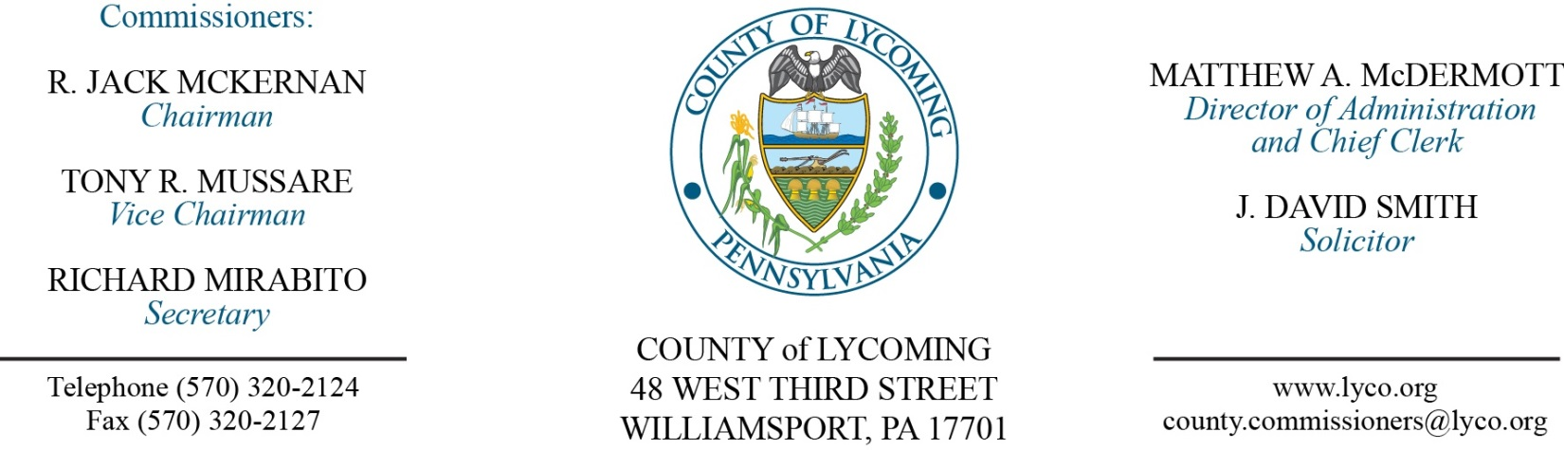
Commissioners’ Meeting Agenda
August 31, 2017

Opening Prayer

Pledge to the Flag

1.0 OPERATIONS

1.1 Convene Commissioners’ meeting.

1.2 Approve the minutes of the previous meetings.

1.3 Receive public comments (agenda items only).

2.0 ACTION ITEMS

2.1 Award purchase agreement to HD Supply Waterworks for the HDPE Pipe items as listed within Bid Price Schedule-A with a total cost of $28,583.46, and QED Environmental Systems, Inc. for the Landfill Gas Well Accessories as listed within Bid Price Schedule-B with a total cost of $4,200.00. (Jason Yorks)

2.2 Approve Amendment #1 to Cleveland Brother Equipment Company, Inc. PSA (Jason Yorks)

2.3 Approve Lehigh County Detainer Agreement 2017 (Mya Toon)

2.4 Approve Sub Recipient Monitoring Agreement between County of Lycoming and
Greater Lycoming Habitat for Humanity (Kim Wheeler)

2.5 Approve the submission of the Lycoming County Children and Youth and Juvenile Justice Services Needs Based Plan and Budget request for the fiscal year July 1, 2018 to June 30, 2019 in the amount of $13,800,842. (Mark Egly)

2.6 Approve child welfare services contract with NHS Pennsylvania for foster care and residential care services at per diems ranging from $29.29/day to $157.04/day for the period July 1, 2016 through June 30, 2017. (Mark Egly)

2.7 Approve child welfare services contract with NHS Pennsylvania for foster care and residential care services at per diems ranging from $29.29/day to $157.04/day for the period July 1, 2017 through June 30, 2018. (Mark Egly)
2.8 Approve child welfare services contract with The Christian Home of Johnstown, Inc. for emergency shelter care services at per diem of $142.85/day for the period July 1, 2017 through June 30, 2018. (Mark Egly)

2.9 Approve Bruce Anderson, M.A. Licensed Psychologist to provide mental health services to Lycoming County Children and Youth Services at the hourly rate of $60, not to exceed $10,000 for the period July 1, 2017 through June 30, 2018. (Mark Egly)

2.10 Approve CWIS Data Sharing Agreement for the period of October 1, 2017 through September 30, 2018. (Mark Egly)

2.11 Approve Dominion Software License Agreement for 2018 (Forrest Lehman)

2.12 Approve Amendment #3 to the GEO Re Entry Services Contract (Ed McCoy)

6.0 COMMISSIONER COMMENT:

7.0 PUBLIC COMMENT:

8.0 NEXT REGULARLY SCHEDULED MEETING: Planning Session on Tuesday, September 5, 2017.

9.0 ADJOURN COMMISSIONERS’ MEETING.

