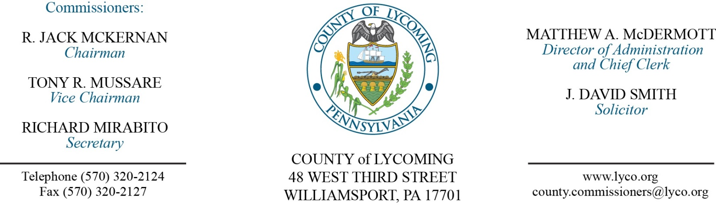
Commissioners’ Meeting Agenda
September 14, 2017

Opening Prayer

Pledge to the Flag

1.0 OPERATIONS

1.1 Convene Commissioners’ meeting.

1.2 Approve the minutes of the previous meetings.

1.3 Receive public comments (agenda items only).

2.0 ACTION ITEMS

2.1 Approve professional service agreement with Aaron Biichle, Esq. for conflict attorney services, not to exceed $40,000/annually. (Adrianne Stahl)

2.2 Approve professional service agreement with Enginutiy for valve replacement at the Prison in the amount of $82,800. (Mya Toon)

2.3 Approve Justice Assistance Grant application in the amount of $11,323 for drug-free water bottle program. (Mya Toon)

2.4 Approve Memorandum of Understanding with the City of Williamsport for the Justice Assistance Grant. (Mya Toon)

2.5 Approve Grant-In-Aid documents for the Juvenile Probation Office as follows: (Nancy Ackley)
Equitable Compensation.
Financial Statement.
Grant Agreement.

2.6 Approve professional service agreement with Valley Youth House for the Juvenile Probation Office. (Nancy Ackley)

2.7 Approve professional service agreement with Diversified Treatment Alternatives for the Juvenile Probation Office. (Nancy Ackley)

2.8 Approve professional service agreement with Outside In for the Juvenile Probation Office. (Nancy Ackley)

2.9 Approve the following personnel actions: (Roxanne Grieco)
PCD – Reclassification of Scott R. Williams as Transportation Planner – Pay grade 9 - $44,963.93/annually effective 9/24/17.

5.0 REPORTS/INFORMATION ITEMS

5.1 LCRMS is requesting bids for GNSG Landfill Compaction System. (Mya Toon)

6.0 COMMISSIONER COMMENT:

7.0 PUBLIC COMMENT:

8.0 NEXT REGULARLY SCHEDULED MEETING: Planning Session on Tuesday, September 19, 2017.

9.0 ADJOURN COMMISSIONERS’ MEETING.

