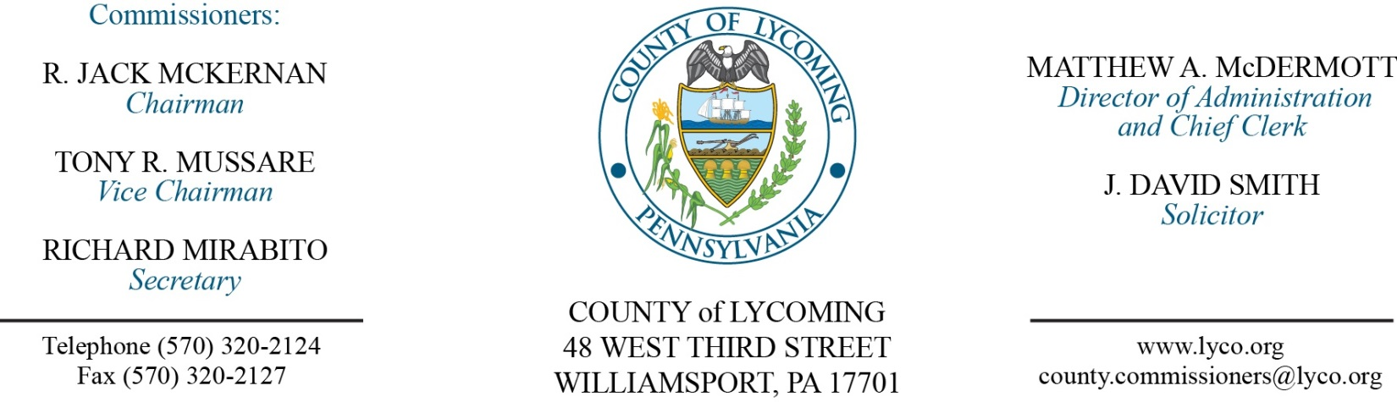
Commissioners’ Meeting Agenda
December 14, 2017

Opening Prayer

Pledge to the Flag

1.0 OPERATIONS

1.1 Convene Commissioners’ meeting.

1.2 Approve the minutes of the previous meetings.

1.3 Receive public comments (agenda items only).

2.0 ACTION ITEMS

2.1 Adopt Resolution 2017-36 for renewal of collateral security note for the Joinder Board line of credit. (Beth Johnston)

2.2 Approve professional service agreement with Contrast Communications, not to exceed $100,000. (Leslie Kilpatrick)

2.3 Approve quote from Mitel Business Systems in the amount of $13,167.14. (Leslie Kilpatrick)

2.4 Approve professional service agreement with Barton Associates in an amount not to exceed $16,900. (Ken George).

2.5 Approve amendment 3 to Act 13 Agreement with South Williamsport extending the agreement to November 30, 2017. (Kurt Hausammann)

2.5 Approve professional service agreement with Tetra Tech, Inc not to exceed $74,000. (Kurt Hausammann)

2.6 Approve professional service agreement with Delta Development not to exceed $124,000. (Kurt Hausammann)

2.7 Approve revision to policy 504.1 Expense Reimbursement of the county policy & procedure manual. (Mya Toon)

2.8 Approve update to policy 410 Reclassification and Promotion of the county policy & procedure manual. (Roxanne Grieco)

2.9 Approve the following personnel actions: (Roxanne Grieco)
Courts – Lois I. Ulmer as part time replacement Clerk III – Pay grade 4 - $12.96/hour effective12/18/2017, not to exceed 1,000 hour annually.
Treasurer – Katherine A. Zay as full time replacement Clerk III – Pay grade 4 - $13.95/hour effective 12/18/2017.
Maintenance – Charles Young as full time replacement Custodial Worker – Pay grade I - $10.84/hour effective 12/18/2017.
District Attorney – promotion of Kacey L. Prichard as full time replacement Clerk III – Pay grade 4 - $13.95/hour effective 12/31/17.
Pre-Release – promotion of Witold Malek as full time replacement Resident Supervisor II – Pay grade 8 - $26.89/hour effective 12/17/17.
Coroner – Jennifer L. Nolan as part time replacement Deputy Coroner/On Call – Pay grade 7 - $21.54/hour effective 12/31/17, not to exceed 1,000 hours annually.
Coroner – Olivia A. Forney as full time replacement Deputy Coroner - Pay grade 7 - $18.08/hour effective 12/31/17.

5.0 REPORTS/INFORMATION ITEMS

5.1 Recognize Leadership Lycoming Class of 2018.

6.0 COMMISSIONER COMMENT:

7.0 PUBLIC COMMENT:

8.0 NEXT REGULARLY SCHEDULED MEETING: Planning Session on Tuesday, December 19, 2017.

9.0 ADJOURN COMMISSIONERS’ MEETING.

