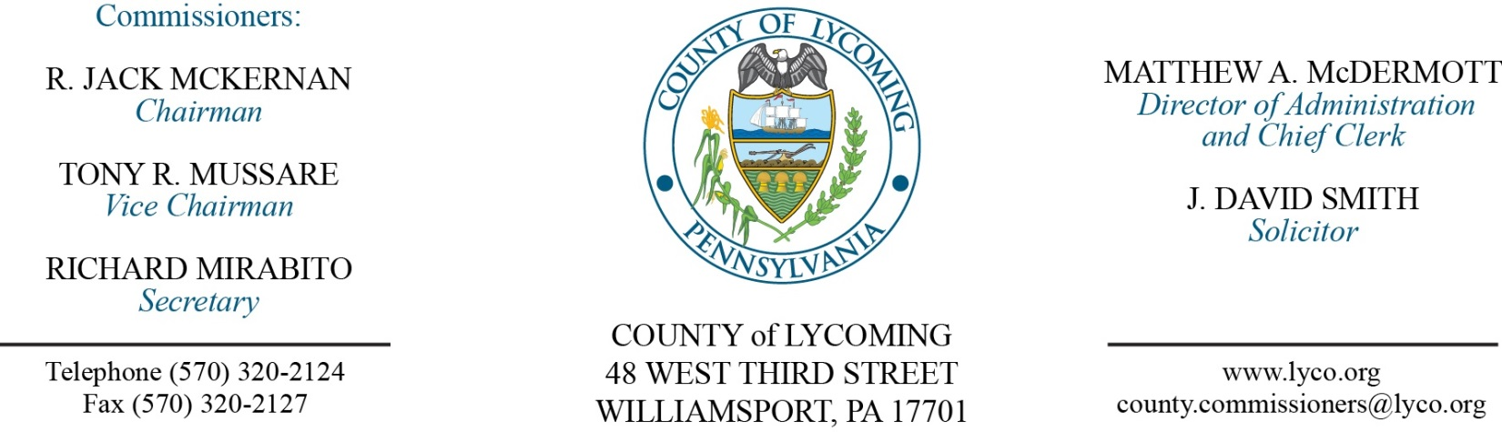
Commissioners’ Meeting Agenda
January 11, 2018

Opening Prayer

Pledge to the Flag

1.0 OPERATIONS

1.1 Convene Commissioners’ meeting.

1.2 Approve the minutes of the previous meetings.

1.3 Receive public comments (agenda items only).

2.0 ACTION ITEMS

2.1 Approve 2018 Certification of Funds for the Ag Preservation Program. (Mark Davidson)

2.2 Approve professional service agreement with George Jr. Republic for JPO. (Nancy Ackley)

2.3 Approve payments not to exceed $139,000 for the Accounts Payables for White Deer Golf Course and payment not to exceed $200,000 for the Line of Credit at Muncy Bank for White Deer Golf Course.

2.4 Approve agreement with CVS Caremark for Prescription Benefit Services. (Ann Gehret)

2.5 Approve interim agreement with Coresource. (Ann Gehret)

2.6 Accept Human Resource report through 12/31/2017. (Ann Gehret)

2.7 Approve the following personnel actions: (Ann Gehret)
DA – DUI Processing Center – Christopher Salisbury as part time replacement Special Detective – DET/DUI - $15.64/hour effective 1/16/18, not to exceed 1,000 hours annually.
DA – Alisha M. Fields as part time replacement Clerk I – pay grade 2 - $10.94/hour effective 1/16/18, not to exceed 1,000 hours annually.
Pre-Release – Brandy L. Perchinski as part time replacement Female Resident Supervisor – Pay grade 5 - $14.14/hour effective 1/22/18, not to exceed 1,000 hours annually.
Pre-Release – Arlene L. Lopez as part time replacement Pre-Release Driver – Pay grade 4 - $12.96/hour effective 1/16/18, not to exceed 1,000 hours annually.
Pre-Release – Karla A. Hanner as part time replacement Pre-Release Driver – Pay grade 4 - $12.96/hour effective 1/16/18, not to exceed 1,000 hours annually.

5.0 REPORTS/INFORMATION ITEMS

5.1 Present JWD award.

5.2 LCRMS is requesting bids for rental equipment. (Marci Hessert)

5.3 Lycoming County is requesting proposals for investment consulting services for the retirement fund. (Nicki Collins)

6.0 COMMISSIONER COMMENT:

7.0 PUBLIC COMMENT:

8.0 NEXT REGULARLY SCHEDULED MEETING: Planning Session on Tuesday, January 16, 2018.

9.0 ADJOURN COMMISSIONERS’ MEETING.

