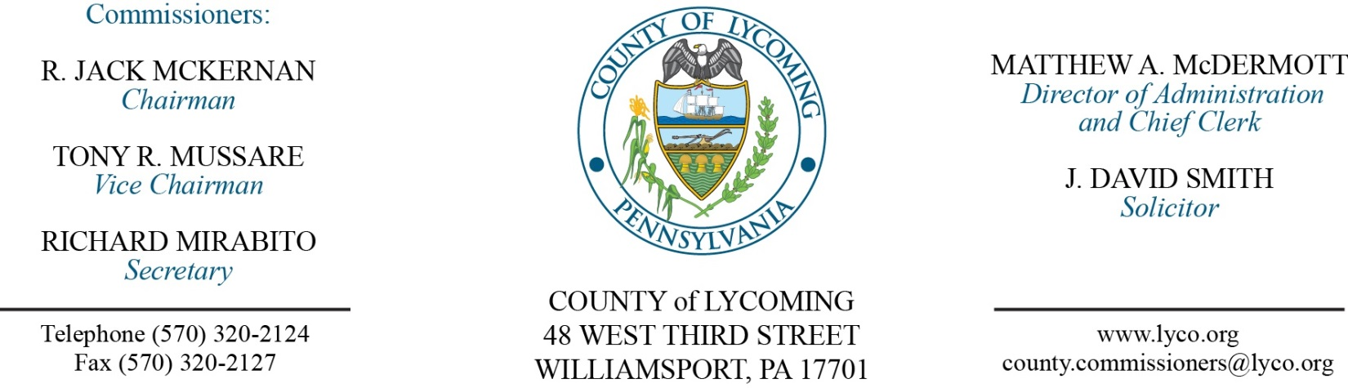
Commissioners’ Meeting Agenda
January 18, 2018

Opening Prayer

Pledge to the Flag

1.0 OPERATIONS

1.1 Convene Commissioners’ meeting.

1.2 Approve the minutes of the previous meetings.

1.3 Receive public comments (agenda items only).

2.0 ACTION ITEMS

2.1 Approve purchase of 1-New 2018 Volvo EC480EL Hydraulic Excavator, EXC-13 with accessories and with trade-in for the total amount of $366,070. (Jason Yorks)

2.2 Approve quote from CBECI in the amount of $61,669 for the rebuild of the engine and torque converter within a 2009 Caterpillar D8T Track Type Tractor. (Jason Yorks)

2.3 Approve FFY 2018 Emergency Management Performance Grant application in the amount of $316,231.54. (Mya Toon)

2.4 Approve invoice for Ready Rosie program in the amount of $19,600.

2.5 Approve professional service agreement with Eaton Corporation. (John Yingling)

2.6 Approve the following personnel actions:
DPS – Communications – Beatrice Scocchera as full time replacement Telecommunicator I – WOE – Pay grade 6 - $16.59/hour effective 1/22/18.
Prothonotary – Elizabeth J. Burkhart as full time replacement Clerk III – Pay grade 4 - $13.95/hour effective 1/29/18.

5.0 REPORTS/INFORMATION ITEMS

5.1 Recognize Jennifer Wahl.

5.2 Lycoming County is requesting bids for management and financing of county vehicles. (Mya Toon)

5.3 Lycoming County is requesting bids for JVB Library Project. (2nd request). (Mya Toon)

6.0 COMMISSIONER COMMENT:

7.0 PUBLIC COMMENT:

8.0 NEXT REGULARLY SCHEDULED MEETING: Planning Session on Tuesday, January 23, 2018.

9.0 ADJOURN COMMISSIONERS’ MEETING.

