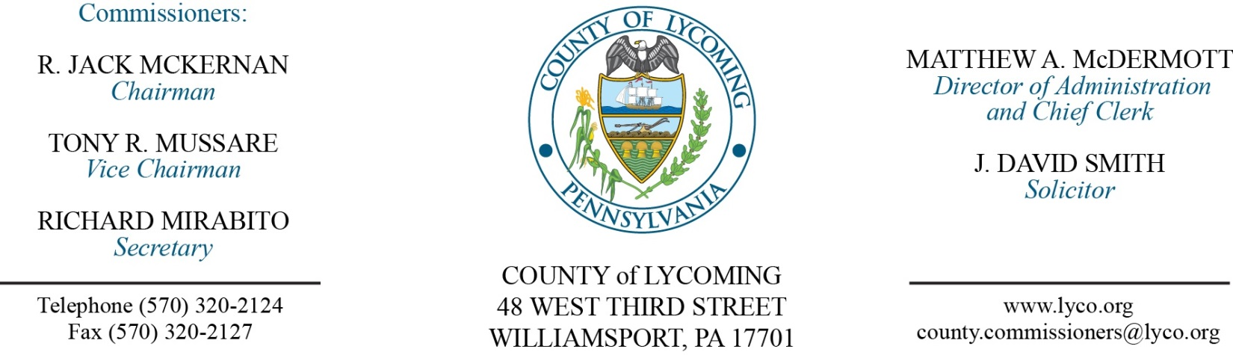
Commissioners’ Meeting Agenda
February 15, 2018

Opening Prayer

Pledge to the Flag

1.0 OPERATIONS

1.1 Convene Commissioners’ meeting.

1.2 Approve the minutes of the previous meetings.

1.3 Receive public comments (agenda items only).

2.0 ACTION ITEMS

2.1 Adopt resolution 2018-03 for stepping up initiative. (President Judge Butts & Keith Wagner, Administrator for MH ID)

2.2 Adopt resolution 2018-04 for donation of $5,000 from Red Run Rod and Gun Club. (Mya Toon)

2.3 Approve grant & monitoring agreement between the County and CAPPA for grant funds in the amount of $30,000. (Mya Toon)

2.4 Approve professional service agreement with Arraya for UCS 2018 server upgrades in the amount of $198,649.06. (Jerry Kennedy)

2.5 Approve professional service agreement with Arraya for 2018 UCS-VMware upgrade in the amount of $25,659. (Jerry Kennedy)

2.6 Approve professional service agreement with Arraya for VMware 2018 additional licensing in the amount of $14,810.80. (Jerry Kennedy)

2.7 Approve agreement with Windstream for internet for the period 2018-2021 in the amount of $1,714/month. (Leslie Kilpatrick)

2.8 Approve professional service agreement with Harris Local Government for the Collections office. (Tom Heap)

2.9 Approve tax collector agreements with the following: (Tom Heap)

Armstrong Township
Bastress Township
Eldred Township
Fairfield Township
Gamble Township]
Hepburn Township
Jackson Township
Jersey Shore Borough
Jordan Township
Limestone Township
Montgomery Borough
Montoursville Borough
Muncy Borough
Muncy Creek Township
Nippenose Township
Penn Township
Picture Rocks Borough
Pine Creek Township
Plunket’s Creek Township
Salladasburg Borough
Upper Fairfield Township
Woodward Township

2.10 Approve agreement with Cleveland Brothers Equipment Company, Inc., for the new replacement undercarriage repair parts in the amount of $23,015.23. (Jason Yorks)

2.11 Approve the following personnel action:
RMS – Operations – Richard Boyer as full time replacement Equipment Operator – Pay grade 5 - $15.22/hour effective 2/20/18.

5.0 REPORTS/INFORMATION ITEMS

5.1 Stephanie Phillips-Taggart, Community Relations Coordinator for the Community Blood Bank.

5.2 Comp Plan review “infrastructure”. (Mark Murawski)

6.0 COMMISSIONER COMMENT:

7.0 PUBLIC COMMENT:

8.0 NEXT REGULARLY SCHEDULED MEETING: Planning Session on Tuesday, February 20, 2018.

9.0 ADJOURN COMMISSIONERS’ MEETING.

