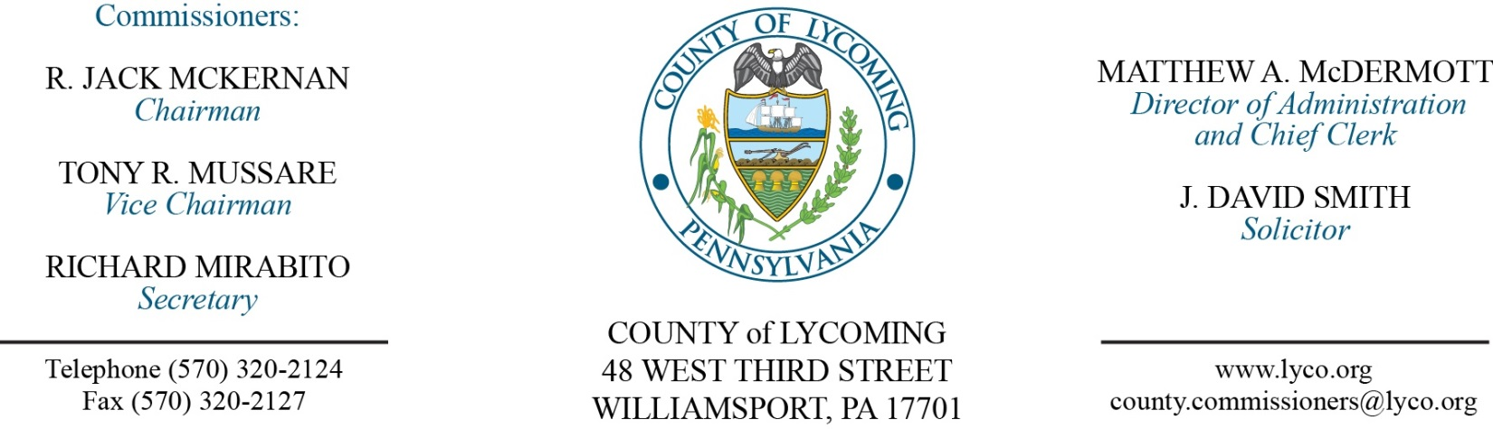
Commissioners’ Meeting Agenda
February 22, 2018

Opening Prayer

Pledge to the Flag

1.0 OPERATIONS

1.1 Convene Commissioners’ meeting.

1.2 Approve the minutes of the previous meetings.

1.3 Receive public comments (agenda items only).

2.0 ACTION ITEMS

2.1 Adopt resolution 2018-05 for RACP grant for the levee project. (Fran McJunkin)

2.2 Adopt resolution 2018-06 for RACP grant for Route 15 water line. (Kurt Hausammann)

2.3 Approve agreement for SAVIN for the Prison. (Mya Toon)

2.4 Approve purchase from Cleveland Brothers Equipment Company, Inc. for a Certified Power Train Rebuild within the 2012 Caterpillar 836H Articulating Landfill Compactor in the amount of $450,000. (Jason Yorks)

2.5 Approve purchase from Cleveland Brothers Equipment Company, Inc. for a Certified Power Train Rebuild within the 2007 Caterpillar D8T Track Type Tractor in the amount of $423,759.62. (Jason Yorks)

2.6 Approve purchase from Green Machine Sales, LLC, for the installation of new replacement repair and wear parts (Stars) used within the Single Stream Recycling System in the amount of $22,492. (Jason Yorks)

2.7 Approve purchase from Susquehanna Motor Company, Inc, for the installation of a reconditioned Mack Truck Engine and related parts within a 2006 Mack CV713 Roll Off Truck in the amount of $25,747.04. (Jason Yorks)

2.8 Approve purchase from Atlantic Tactical for 18-Ballistic Helmets in the amount of $12,873. (Chief Deputy Ulmer)

2.9 Approve the following personnel action: (Roxanne Grieco)
Courts – MDJ Kemp – Karen O. Bullis as full time replacement Clerk IV – Pay grade 5 - $18.47/hour effective 4/1/18.

Recess Commissioners’ Meeting

4.0 BOARD of ASSESSMENT REVISION

4.1 Convene Board of Assessment Revision.

4.2 Approve real estate exonerations (see attached list).

4.3 Approve real estate refund:
Parcel 43-349-123.R – Gregory & Donna Banzhaf - $356.76.

4.4 Adjourn Board of Assessment Revision.

Reconvene Commissioners’ Meeting

5.0 REPORTS/INFORMATION ITEMS

5.1 Present JWD to Nicki Brelsford.

5.2 Comp Plan presentation “Economy”. (Jenny Picciano/Kim Wheeler)

6.0 COMMISSIONER COMMENT:

7.0 PUBLIC COMMENT:

8.0 NEXT REGULARLY SCHEDULED MEETING: Planning Session on Tuesday, February 27, 2018.
9.0 ADJOURN COMMISSIONERS’ MEETING.

Date | Parcel Number | Owner's Name | Site Location | From Value | To Value | Diff | Cty Taxes | Reason | Years Exoned
2/22/2018 | 59-374-154.A-031 | Adam Summers | 55 Willow St | 7650 | 0 | -7650 | ($49.73) | Trailer Razed | 2016-2017
2/22/2018 | 11-310-136.10-008 | Thomas Pittenger | 170 Pinecrest Dr Lt 8 | 2030 | 0 | -2030 | ($13.20) | Trailer Razed | 2017
2/22/2018 | 12-331-142 | Harold & Dena Mesaris | 952 Rt 87 Hwy | 202320 | 0 | -202320 | ($1,315.08) | Veteran's Exemption | 2018
2/22/2018 | 61-004-701 | Water Tower Square | 1020 Commerce Park Dr | 1615920 | 1532820 | -83100 | ($540.15) | Lerta (2 years left) | 2018
2/22/2018 | 71-001-301 | Lundy Industrial Realty | 240R Arch St | 3961940 | 3729790 | -232150 | ($1,508.98) | Lerta (2 years left) | 2018
2/22/2018 | 63-001-101 | Paul G Enterprises Inc | 100 Pine St | 8662060 | 8188740 | -473320 | ($3,076.58) | Lerta (1 year left) | 2018
2/22/2018 | 62-004-402 | Blackhorse Holdings | 209 E Third St | 696800 | 673000 | -23800 | ($154.70) | Lerta (3 years left) | 2018
2/22/2018 | 62-004-403 | Blackhorse Holdings | 215 E Third St | 247750 | 230250 | -17500 | ($113.75) | Lerta (3 years left) | 2018
2/22/2018 | 64-005-605 | Bennardi Sisters LLC | 414 W Fourth St | 309500 | 268390 | -41110 | ($267.22) | Lerta (3 years left) | 2018
2/22/2018 | 65-007-328 | Staiman Real Estate | 206 Walnut St | 659820 | 465090 | -194730 | ($1,265.75) | Lerta (3 years left) | 2018
2/22/2018 | 63-002-308.A | Chartwell Church St LLC | 10 W Church St | 3728070 | 2288070 | -1440000 | ($9,360.00) | Lerta (3 years left) | 2018
2/22/2018 | 63-002-602 | Chartwell Church St LLC | 150 W Church St | 4551800 | 2147330 | -2404470 | ($15,629.06) | Lerta (5 years left) | 2018
2/22/2018 | 62-003-100 | Bradi & Casey Stopper | 300 E Church St | 365180 | 178600 | -186580 | ($1,212.77) | Lerta (5 years left) | 2018
2/22/2018 | 72-002-218 | Baltic Avenue Properties | 621 Hepburn St | 613350 | 475310 | -138040 | ($897.26) | Lerta (6 years left) | 2018
2/22/2018 | 23-338-132 | Watson Irrev Grantor Trust | 4930 Rt 239 Hwy | 69750 | 40070 | -29680 | ($192.92) | 2nd cabin is assessed in Columbia Cty | 2018
2/22/2018 | 23-338-132 | Watson Irrev Grantor Trust | 4930 Rt 239 Hwy | 29680 | 0 | -29680 | ($192.92) | Void interim for 2nd cabin | 2018
2/22/2018 | 59-314-157.G | Gwen Lentz | 415 Lower Rynearson Rd | 131060 | 0 | -131060 | ($851.89) | Duplicate Interims | 2017
2/22/2018 | 34A-008-331 | James & Lisa Bennett | Willow St | 36580 | 0 | -36580 | ($237.77) | Combined w/ 332 per appeal | 2018
2/22/2018 | 34A-008-332 | James & Lisa Bennett | 815 Willow St | 254100 | 182120 | -71980 | ($467.87) | Change per appeal | 2018
2/22/2018 | 34A-008-332 | James & Lisa Bennett | 815 Willow St | 32380 | 0 | -32380 | ($210.47) | No Interim | 2017
2/22/2018 | 43-005-111 | Lock-Cuff Inc | 2254 Mill Ln | 121040 | 22110 | -98930 | ($643.05) | Spec House | 2018
2/22/2018 | 43-005-111 | Lock-Cuff Inc | 2254 Mill Ln | 98940 | 0 | -98940 | ($643.11) | Spec House No Interim | 2017
2/22/2018 | 56-002-103 | Aaron Hepler | 1971 Rt 87 Hwy | 204050 | 0 | -204050 | ($1,326.33) | Veteran's Exemption | 2018
2/22/2018 | 24-001-100 | Paul & Julie Santos | 131 Truman St | 113800 | 0 | -113800 | ($739.70) | Veteran's Exemption | 2018
2/22/2018 | 59-354-191.44 | Luke & Mitzi Herron | 171 Trinity Dr | 198560 | 191270 | -7290 | ($47.39) | Change per appeal | 2018
2/22/2018 | 59-354-191.44 | Luke & Mitzi Herron | 171 Trinity Dr | 198560 | 191270 | -7290 | ($47.39) | Correct Interim | 2017
2/22/2018 | 15-001-203.A | Hepburn Township | 336 W Creek Rd | 72530 | 0 | -72530 | ($471.45) | Fema Buyout | 2018
2/22/2018 | 17-002-111 | Buck Lumber Company | 171 S Railroad St | 78260 | 23340 | -54920 | ($356.98) | House razed | 2018

