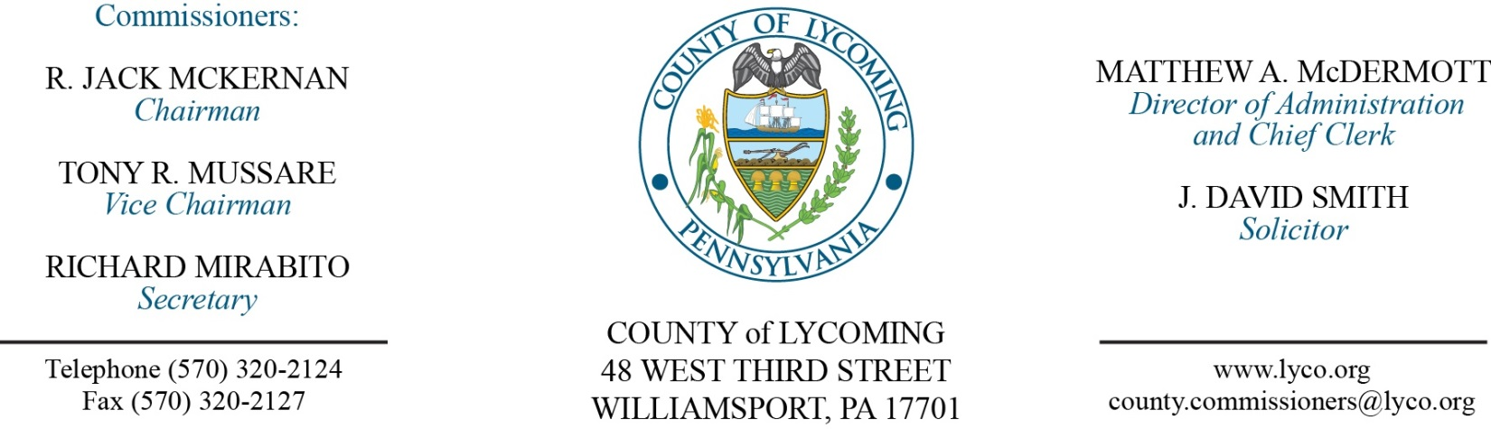
Commissioners’ Meeting Agenda
March 29, 2018

Opening Prayer

Pledge to the Flag

1.0 OPERATIONS

1.1 Convene Commissioners’ meeting.

1.2 Approve the minutes of the previous meetings.

1.3 Receive public comments (agenda items only).

2.0 ACTION ITEMS

2.1 Proclaim March as “Red Cross Month” in Lycoming County.

2.2 Proclaim the month of April as “Pennsylvania 811 Safe Digging Month.” (Mark Lipka)

2.3 Approve professional service agreement with Trisha Hoover Jasper for Conflict Attorney for 2018-19. (Adrianne Stahl)

2.4 Approve professional service agreement with PA Window Tint. (Ken George)

2.5 Approve right of way with PP&L. (Ken George)

2.6 Award contracts for James V Brown Library remodel to: (Mya Toon)
Best Quality Builders in the amount of $70,663.00 for work sections A-F.
SupplySource in the amount of $15,958.38 for office furniture.

2.7 Approve professional service agreement with PA Firearm Commission. (Nancy Ackley)

2.8 Approve purchase of a 2018 Silt Sock Attachment from Silt Sock Erosion Control Products $10,474.47. (Jason Yorks)

2.9 Approve DEP 903 Recycling Coordinator grant application in the amount of $35,480.72. (Jason Yorks)

2.10 Accept HR report through March 29, 2018. (Lauren Bower)

2.11 Approve the following personnel action: (Lauren Bower)
RMS – Resource Recovery – Justin Kontz as full time replacement Truck Driver – Pay grade 5 - $15.22/hour effective 4/2/18.

5.0 REPORTS/INFORMATION ITEMS

5.1 Comp Plan review “Water Quality”. (Josh Billings)

6.0 COMMISSIONER COMMENT:

7.0 PUBLIC COMMENT:

8.0 NEXT REGULARLY SCHEDULED MEETING: Planning Session on Tuesday, April 3, 2018.

9.0 ADJOURN COMMISSIONERS’ MEETING.

