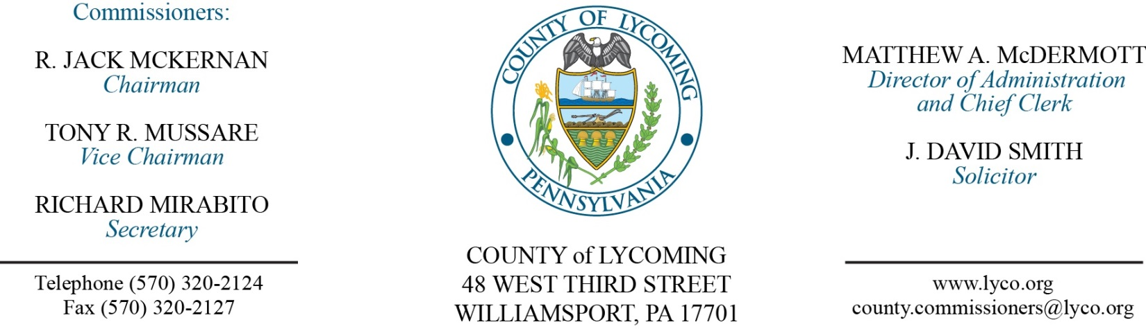
Commissioners’ Meeting Agenda
May 3, 2018

Opening Prayer

Pledge to the Flag

1.0 OPERATIONS

1.1 Convene Commissioners’ meeting.

1.2 Approve the minutes of the previous meetings.

1.3 Receive public comments (agenda items only).

2.0 ACTION ITEMS

2.1 Approve professional service agreement with Dr. Leo Kadehjian, not to exceed $10,000. (Mya Toon)

2.2 Award contract for Master Leasing to Transitional Living Centers. (Thomas Krajewski)

2.3 Approve Master Leasing Sub-recipient Agreement with Transitional Living Centers in the amount of $292,500. (Thomas Krajewski)

2.4 Accept Human Resources report through 4/30/2018. (Roxanne Grieco)

2.5 Approve update to the TDA – Veteran’s Affairs – addition of Temporary Part-time Veterans Affairs Assistant. (Roxanne Grieco)

2.6 Approve the following personnel actions: (Roxanne Grieco)
Prison – Stephen S. George as full time replacement Rover – CO2 - $22.47/hour effective 6/3/18.
Prison – promotion of Michael D. Minier to full time replacement Intake Officer – CO2 - $17.99/hour effective 6/3/18.
Prison – Jason C. Eiswerth as full time replacement Central Control Operator – CO2 - $20.96/hour effective 6/3/18.
Prison – Amilee Miller as full time replacement Correctional Officer Female relief M/F – CO1 - $16.01/hour effective 5/21/18.
Pre-Release – reclassification of Jamie L. Shoemaker to full time resident Supervisor – Pay grade 6 - $17.95/hour effective 6/3/18.
Assessment – Ashley M. Beatty as full time replacement Field Assessor – Pay grade 5 - $15.22/hour effective 5/9/18.
Veterans Affairs – Frank J. Passaniti as part time Temporary Veterans Affairs Assistant – Pay grade 7 - $16.83/hour effective 5/6/18.
District Attorney – full time replacement Assistant County Detective – NEU - AD - $22.042365/hour effective 5/6/18.

Recess Commissioners’ Meeting

3.0 SALARY BOARD

3.1 Convene Salary Board.

3.2 Approve update to the salary schedule to include the Temporary Part-time Veterans Affairs Assistant.

3.3 Appoint as special county detectives individuals for the Narcotics Enforcement Unit.

3.4 Adjourn Salary Board.

Reconvene Commissioners’ Meeting

5.0 REPORTS/INFORMATION ITEMS

5.1 Recognize Kevin DeParlos on his retirement.

5.2 Request bids for food products. (Mya Toon)

5.3 Request bids for bread products. (Mya Toon)

6.0 COMMISSIONER COMMENT:

7.0 PUBLIC COMMENT:

8.0 NEXT REGULARLY SCHEDULED MEETING: Planning Session on Tuesday, May 8, 2018.

9.0 ADJOURN COMMISSIONERS’ MEETING.

