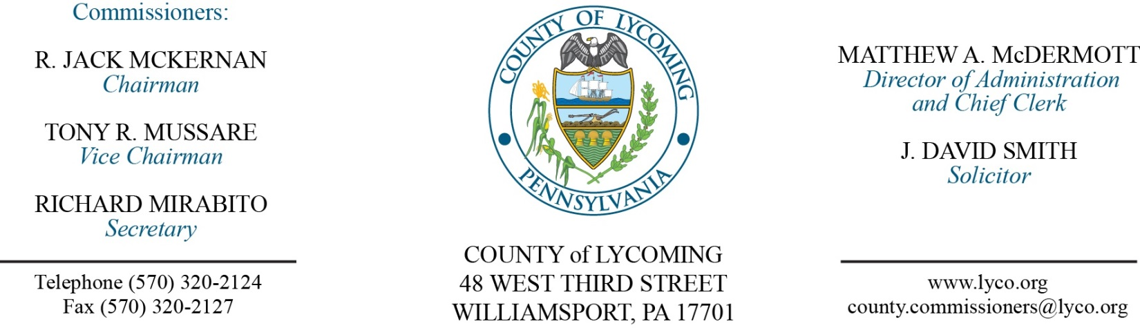
Commissioners’ Meeting Agenda
May 31, 2018

Opening Prayer

Pledge to the Flag

1.0 OPERATIONS

1.1 Convene Commissioners’ meeting.

1.2 Approve the minutes of the previous meetings.

1.3 Receive public comments (agenda items only).

2.0 ACTION ITEMS

2.1 Approve professional service agreement with Barr Construction for PRC roof repair in the amount of $10,430. (Ken George)

2.2 Approve grant agreement with the Department of Health in the amount of $278,291. (Wendy Hastings)

6.0 COMMISSIONER COMMENT:

7.0 PUBLIC COMMENT:

8.0 NEXT REGULARLY SCHEDULED MEETING: Planning Session on Tuesday, June 5, 2018.

9.0 ADJOURN COMMISSIONERS’ MEETING.

