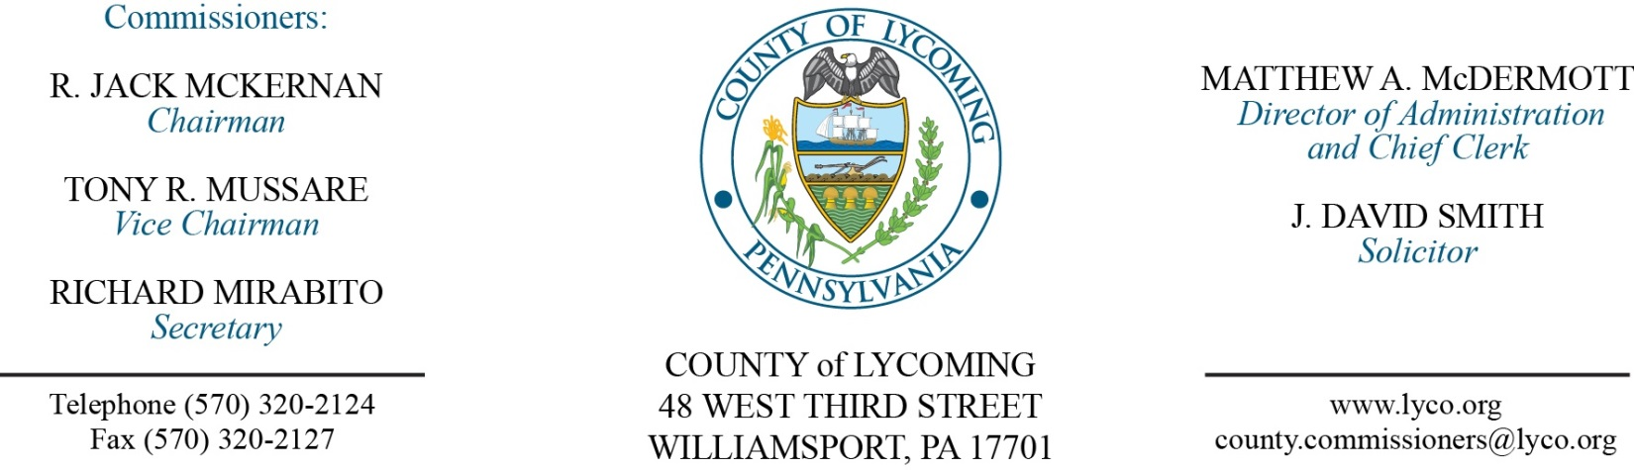
Commissioners’ Meeting Agenda
June 28, 2018

Opening Prayer

Pledge to the Flag

1.0 OPERATIONS

1.1 Convene Commissioners’ meeting.

1.2 Approve the minutes of the previous meetings.

1.3 Receive public comments (agenda items only).

Recess Commissioners’ Meeting

Public Hearing for Franklin Township/Lairdsville CDBG competitive application.
(Kristin McLaughlin)

Reconvene Commissioners’ Meeting

2.0 ACTION ITEMS

2.1 Adopt resolution 2018-17 for Franklin Township/Lairdsville CDBG competitive application. (Kristin McLaughlin)

2.2 Approve 2018 PHARE grant agreement. (Kim Wheeler)

2.3 Approve amendment 2 to 2014 PHARE (SHP) Subrecipient Agreement. (Jenny Picciano)

2.4 Adopt resolution 2018-18 for the Lycoming County Comprehensive plan. (Kurt Hausammann)

2.5 Reappoint Michael Sherman and Howard Fry to the Lycoming County Planning Commission with term expirations of 12/31/21. (Kurt Hausammann )

2.6 Adopt resolution 2018-16 for Growing Greener Plus grant request of $149,746.25. (Josh Schnitzlein)

2.7 Approve purchase from Topcon Solutions in the amount of $13,488.39. (Amy Fry)

2.8 Approve update to the TDA – Treasurer’s Office - addition of one part time temporary clerk; Collections – addition of one (1) Temporary Clerk I position; Domestic Relations –change FT Domestic Relations Investigator and PT Domestic Relations Investigator position to Union Contract (Detective). (Roxanne Grieco)

2.9 Approve the following personnel actions: (Roxanne Grieco)
Courts – Judge Butts - Kevin M. Packer, Jr. as full time replacement Law Clerk – Pay grade 8 - $38,548.49/annually, effective 8/6/18.
Pre-Release – Keely Shae Whipple as part time replacement Female Resident Supervisor – Pay grade 5 - $14.14/hour, effective 7/2/18, not to exceed 1,000 hours annually.
Pre-Release – Rickie Sue Berkheiser as part time replacement Female Resident Supervisor – Pay grade 5 - $14.14/hour, effective 7/2/18, not to exceed 1,000 hours annually.
District Attorney – DUI Center – Jacob W. Summers as part time replacement Special Detective – DUI Center – DET2 - $15.64/hour, effective 7/2/18, not to exceed 1,000 hours annually.
Prothonotary – Denise Gusbar as full time replacement Data Entry Operator (Legal) – Pay grade 4 - $13.95/hour, effective 7/2/18.
Treasurer – Morgan E. Heap as part time Clerk I (Temporary) – Pay grade 2 - $10.94/hour, effective 7/9/18, not to exceed 1,000 hours annually.

2.10 Accept HR report through June 28, 2018. (Roxanne Grieco)

Recess Commissioners’ Meeting

3.0 SALARY BOARD

3.1 Convene Salary Board.

3.2 Approve update to the 2018 Salary Schedule - Treasurer’s Office - addition of one part time temporary clerk; Collections – addition of one (1) Temporary Clerk I position; Domestic Relations –change FT Domestic Relations Investigator and PT Domestic Relations Investigator position to Union Contract (Detective).

3.3 Approve update to the 2018 Salary Schedule -RMS - Comptroller/Business Manager salary.

3.4 Adjourn Salary Board.

Reconvene Commissioners’ Meeting

5.0 REPORTS/INFORMATION ITEMS

5.1 Recognize Sue Preston on her retirement (District Attorney)

5.2 Present JWD awards (21).

6.0 COMMISSIONER COMMENT:

7.0 PUBLIC COMMENT:

8.0 NEXT REGULARLY SCHEDULED MEETING: Planning Session on Tuesday, July10, 2018. No meetings July 2 or 5.

9.0 ADJOURN COMMISSIONERS’ MEETING.

