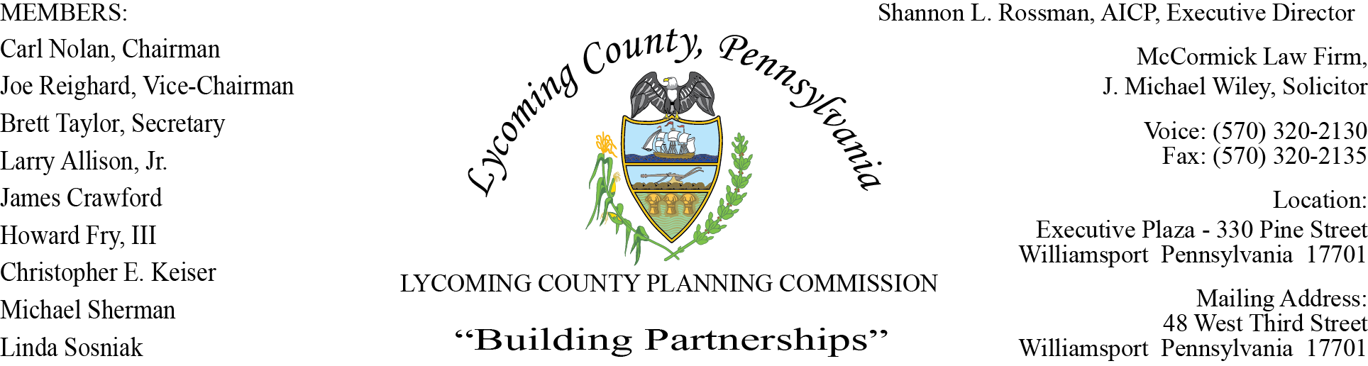

LYCOMING COUNTY PLANNING COMMISSION MEETING
Executive Plaza Building
June 17, 2021
6:00pm

MEMBERS PRESENT: Joe Reighard, Jason Bogle, Brett Taylor, Linda Sosniak, Chase Kelch,
Howard Fry III, Jim Crawford, Carl Nolan

MEMBERS ABSENT: Larry Allison Jr
MEMBERS PRESENT VIA CONFERENCE CALL:
OTHERS PRESENT VIA CONFERENCE CALL:

OTHERS PRESENT: Shannon Rossman, PCD, John Lavelle, PCD, Tiffany Krajewski, PCD,
Heather George, PCD, J. Michael Wiley, Solicitor, Mike Ruther, Sun-Gazette,
Chris Hodges, PCD, Mark Haas, PCD

- CALL TO ORDER

Joe Reighard, Chairman, called the meeting to order at 6:00pm.

- MINUTES OF REGULAR MEETING

Joe Reighard asked for motion to accept the May 20, 2021 meeting minutes.
Howard Fry, III motion to approve, Linda Sosniak, second to approve. Motion carried.

- PUBLIC COMMENT ON AGENDA ITEMS ONLY – None

- OLD & FUTURE BUSINESS

- SUBDIVISION & LAND DEVELOPMENT PLANS

- Multi-Lot Presentations - None

- Land Development

- Andrew & Joan McNally
Single0Lot Subdivision Denial
Shrewsbury Township

- VIWY
Two Fast Food Restaurant Land Development
Muncy Township

- Single-Lot Ratifications

Mark Haas asked members if they had any questions on the Minor Plans Report.

There were no questions from members on the single-lot ratifications.

Brett Taylor made motion to approve, Chase Kelch, second motion. Motion carried.

- ACTION ITEMS

- COMMITTEE REPORTS/DISCUSSION

- MONTHLY REPORTING

Shannon expressed to members these are standard monthly reports if they have any questions to contact the individual staff.

- DISCUSSION ITEMS

- PUBLIC COMMENTS - None

- ADJOURNMENT

Joe Reighard asked for a motion to adjourn, Brett Taylor, motion to adjourn, Carl Nolan second motion. Motion carried.
Meeting adjourned at 6:46 pm.

Respectfully submitted,

_________________________ _________________________
Shannon L. Rossman, Director Carl Nolan, Secretary

DATE: ____________ DATE: _____________

